
Hospital Management System: A Web Application
Production Pilot with Adaptive Queue and Role Aware Assistance
By
Md. Sobuj Mia
ID: 0242220005101064
Md. Ismail Hossain
ID: 0242220005101051
FINAL YEAR DESIGN PROJECT REPORT
This report is presented in partial fulfillment of the requirements for the degree of Bachelor of Science in Computer Science and Engineering.
Supervised by
Md. Ferdouse Ahmed Foysal
Lecturer
Department of Computer Science and Engineering
Co-Supervised by
Shah Md. Tanvir Siddiquee
Lecturer
Department of Computer Science and Engineering
DAFFODIL INTERNATIONAL UNIVERSITY
Dhaka, Bangladesh
September 05, 2026

APPROVAL
This project titled “Hospital Management System: A Web Application”, submitted by Md. Sobuj Mia and Md. Ismail Hossain to the Department of Computer Science and Engineering, Daffodil International University, has been prepared in partial fulfillment of the requirements for the degree of Bachelor of Science in Computer Science and Engineering. The work, report, demonstration, and supporting evidence are presented for academic evaluation and approval as to their style and contents.
Supervisor signature: ____________________________________
Md. Ferdouse Ahmed Foysal
Lecturer, Department of Computer Science and Engineering
Daffodil International University
Co-supervisor signature: _________________________________
Shah Md. Tanvir Siddiquee
Lecturer, Department of Computer Science and Engineering
Daffodil International University
Date: ____________________

BOARD OF EXAMINERS
Name and signature: ______________________________________
Board Chairman
Department of Computer Science and Engineering
Daffodil International University

Name and signature: ______________________________________
Internal Examiner 1
Department of Computer Science and Engineering
Daffodil International University

Name and signature: ______________________________________
Internal Examiner 2
Department of Computer Science and Engineering
Daffodil International University

Name and signature: ______________________________________
External Examiner
Department of Computer Science and Engineering
Daffodil International University

DECLARATION
We hereby declare that the project described in this report was completed by us under the supervision of Md. Ferdouse Ahmed Foysal, Lecturer, Department of Computer Science and Engineering, Daffodil International University, and the co-supervision of Shah Md. Tanvir Siddiquee, Lecturer, Department of Computer Science and Engineering, Daffodil International University. We further declare that this project, or any substantial part of it, has not been submitted elsewhere for the award of another degree or diploma. Sources used in the analysis and design are acknowledged in the references.
Supervised by:
Signature: ____________________
Md. Ferdouse Ahmed Foysal
Lecturer, Department of Computer Science and Engineering
Daffodil International University
Co-supervised by:
Signature: ____________________
Shah Md. Tanvir Siddiquee
Lecturer, Department of Computer Science and Engineering
Daffodil International University
Submitted by:
Signature: ____________________
Md. Sobuj Mia
ID: 0242220005101064
Department of Computer Science and Engineering
Daffodil International University
Submitted by:
Signature: ____________________
Md. Ismail Hossain
ID: 0242220005101051
Department of Computer Science and Engineering
Daffodil International University

ACKNOWLEDGEMENTS
First, we are grateful to Almighty Allah for giving us the patience and ability to complete this final year project. The work began as a small appointment system and grew into a carefully bounded hospital operations pilot. That change required us to revisit assumptions, correct earlier documentation, and test the system as a working service rather than only as a classroom demonstration.
We express our sincere gratitude to our supervisor, Md. Ferdouse Ahmed Foysal, and our co-supervisor, Shah Md. Tanvir Siddiquee, both from the Department of Computer Science and Engineering at Daffodil International University. Their guidance helped us connect software design decisions with the responsibility involved in handling patient identity, schedules, queues, and operational records.
We also thank the faculty members, classmates, and family members who supported the work. The interface review, repeated role walkthroughs, and discussion of real reception and doctor workflows were especially useful. Finally, we acknowledge the maintainers of the open standards, research literature, frameworks, and tools cited in this report. Their public technical material allowed the system to be developed with verifiable rather than invented assumptions.

ABSTRACT
Hospitals lose time and create avoidable uncertainty when appointment booking, reception check in, queue progress, onsite payment recording, and communication are kept in separate manual processes. This project develops a web based hospital operations pilot for one small hospital with up to 30 doctors, 500 appointments in a day, and 50 concurrent users. The system provides separate workspaces for patients, doctors, receptionists, and administrators. It covers doctor directories, schedules and closures, patient registration with generated medical record numbers, appointment booking and rescheduling, walk ins, check in, live privacy safe queue tokens, onsite BDT payment status, notifications, consent, and immutable audit evidence. The implementation uses React 19, Django 5.2 LTS, Django REST Framework, PostgreSQL 18, Caddy, and Docker. Transactional domain services combine row locks, uniqueness constraints, idempotency records, state validation, and business histories to protect competing operations. The main design contribution is an Adaptive Arrival Window that combines the configured visit duration with recent valid service durations and reports a bounded wait range without performing clinical triage or changing first in first out order. A read only role aware assistant explains workflows and uses only allowlisted live facts. It retains a deterministic local answer path when the optional external language provider is unavailable. The completed local candidate passed 129 Django tests with 87 percent line coverage, 57 frontend tests with 88.88 percent line coverage, six Chromium workflow scenarios, security and dependency checks, a 50 user quick read test, and an encrypted backup restoration exercise. Real patient use remains intentionally blocked until the hospital approves its identity, privacy and retention rules, legal review, staff access, external infrastructure, restoration evidence, and signed user acceptance. The result is therefore a tested production candidate and academic implementation, not a claim of unrestricted clinical deployment.

TABLE OF CONTENTS
APPROVAL i
BOARD OF EXAMINERS ii
DECLARATION iii
ACKNOWLEDGEMENTS iv
ABSTRACT v
TABLE OF CONTENTS vi
LIST OF FIGURES x
LIST OF TABLES xii
LIST OF ABBREVIATIONS xiv
INTRODUCTION 1
1.1 Background and Problem Statement 1
1.2 Motivation 1
1.3 Objectives 2
1.4 Scope and Boundary 3
1.5 Development Method 3
1.6 Project Outcome 4
1.7 Organization of the Report 5
BACKGROUND 6
2.1 Domain Background 6
2.2 Literature Review 6
2.3 Similar Applications 7
2.4 Gap Analysis 8
2.5 Novelty Boundary 8
2.6 Summary 9
REQUIREMENT ANALYSIS AND DESIGN SPECIFICATION 10
3.1 Stakeholders and Operating Assumptions 10
3.2 Role and System Context 11
3.3 Functional Requirements 11
3.4 Nonfunctional Requirements 12
3.5 Architecture 13
3.6 Data Model and Integrity 14
3.7 Appointment and Queue State Design 15
3.8 API Contract 16
3.9 Adaptive Arrival Window 17
3.10 Role Aware Assistant 18
3.11 Security and Privacy Design 19
3.12 User Interface and Accessibility Design 19
3.13 Alternatives Considered 20
3.14 Project Plan and Task Allocation 20
3.15 Summary 21
IMPLEMENTATION AND RESULTS 22
4.1 Development and Runtime Environment 22
4.2 Backend Implementation 22
4.3 Frontend Implementation 23
4.4 Deployment Implementation 24
4.5 Implemented Interface Evidence 24
4.6 Software Quality Assurance 36
4.7 Critical Test Scenarios 37
4.8 Performance and Capacity Interpretation 38
4.9 Results and Discussion 38
4.10 Summary 39
ENGINEERING STANDARDS AND DESIGN CHALLENGES 40
5.1 Applicable Standards and Guidance 40
5.2 Hardware and Software Constraints 40
5.3 Communication and Interoperability 41
5.4 Social, Health, Safety and Cultural Impact 41
5.5 Ethical and Privacy Responsibilities 41
5.6 Sustainability 42
5.7 Project Management and Financial Analysis 42
5.8 Complex Engineering Problem Mapping 43
5.9 Knowledge Profile Mapping 43
5.10 Complex Engineering Activities 43
5.11 Principal Design Challenges 44
5.12 Summary 44
CONCLUSION 45
6.1 Summary 45
6.2 Limitations 45
6.3 Future Work 46
6.4 Final Statement 46
REFERENCES 48
APPENDIX A: API INVENTORY 50
APPENDIX B: DETAILED MANUAL TEST CATALOGUE 50
APPENDIX C: DEMONSTRATION ACCOUNTS 51
APPENDIX D: DEPLOYMENT AND GO LIVE CHECKLIST 51
APPENDIX E: REQUIREMENT TRACEABILITY 52
APPENDIX F: SUBMISSION ARTIFACT INDEX 53

LIST OF FIGURES
Figure 1.1: Incremental delivery and verification method 4
Figure 3.1: Role and access context 11
Figure 3.2: System architecture 13
Figure 3.3: Core data model 14
Figure 3.4: Appointment and queue workflow 15
Figure 3.5: Adaptive Arrival Window calculation 17
Figure 3.6: Role aware help assistant 18
Figure 4.1: Pilot deployment and recovery topology 24
Figure 4.2: Public home page with hospital service entry points 25
Figure 4.3: Public doctor directory 26
Figure 4.4: Patient dashboard 27
Figure 4.5: Appointment booking workflow 28
Figure 4.6: Patient assistant showing live availability 28
Figure 4.7: Reception dashboard 29
Figure 4.8: Reception view after appointment check in 30
Figure 4.9: Doctor dashboard 31
Figure 4.10: Doctor assistant workload answer 31
Figure 4.11: Doctor queue after calling the next patient 32
Figure 4.12: Patient live queue 33
Figure 4.13: Administrator dashboard 34
Figure 4.14: Administrator schedule management 35
Figure 4.15: Administrator audit search 36
Figure 4.16: Administrator assistant summary 36

LIST OF TABLES
Table A.1: Abbreviations used in the report xiv
Table 1.1: Release scope and exclusions 3
Table 2.1: Summary of literature reviewed 7
Table 2.2: Public capability comparison 8
Table 2.3: Observed gaps and design response 8
Table 3.1: Stakeholders and principal needs 10
Table 3.2: Functional requirements 11
Table 3.3: Nonfunctional requirements 12
Table 3.4: Core data dictionary 14
Table 3.5: Versioned API groups 16
Table 3.6: Security and privacy controls 19
Table 3.7: Design alternatives 20
Table 3.8: Project activity plan 20
Table 4.1: Implementation environment 22
Table 4.2: Verification result summary 37
Table 4.3: Representative critical test cases 37
Table 5.1: Standards and guidance mapping 40
Table 5.2: Cost categories for procurement 42
Table 5.3: Mapping with complex engineering problem characteristics 43
Table 5.4: Mapping with knowledge profile 43
Table 5.5: Mapping with complex engineering activities 43
Table 5.6: Design challenges and resolution 44
Table A.2: Principal API endpoints 50
Table B.1: Manual role test catalogue 50
Table C.1: Synthetic demonstration identities 51
Table E.1: Requirement to implementation and evidence mapping 52
Table F.1: Maintained submission artifacts 53

LIST OF ABBREVIATIONS
Table A.1: Abbreviations used in the report
Abbreviation | Meaning
API | Application Programming Interface
ASVS | Application Security Verification Standard
CSRF | Cross Site Request Forgery
ETag | HTTP entity tag used for conditional queue reads
FHIR | Fast Healthcare Interoperability Resources
FYDP | Final Year Design Project
MFA | Multi Factor Authentication
MRN | Medical Record Number
RPO | Recovery Point Objective
RTO | Recovery Time Objective
SQA | Software Quality Assurance
TOTP | Time Based One Time Password
UAT | User Acceptance Testing
WCAG | Web Content Accessibility Guidelines

CHAPTER 1

INTRODUCTION
This chapter explains the hospital operations problem, the reason for building the system, the precise objectives, the implementation boundary, and the method used to turn the original academic idea into a verifiable production candidate.

1.1 Background and Problem Statement
An outpatient visit begins before a patient enters a consultation room. The patient has to find an appropriate doctor, understand where and when that doctor works, obtain a valid appointment, arrive at the correct location, report to reception, wait for a fair turn, and receive confirmation when the visit ends. Reception staff must identify the patient correctly, avoid duplicate records, protect the final available capacity, accommodate walk ins, and explain delays. Doctors need a current view of their own queue without gaining unrelated access. Administrators have to configure services and retain enough evidence to understand who changed what. A weak system may display a polished dashboard while still allowing double booking, exposure of another patient, or an unexplained queue override.
The supplied university proposal described a basic appointment application. It did not provide transferred source code, a trustworthy data model, role boundaries, concurrency rules, an audit design, backup evidence, or a defensible production scope. Several sample interface images exposed patient names in queue contexts, and the supplied bibliography could not be verified as written. Treating those materials as complete requirements would have created risk. The project was therefore reanalysed from the beginning, while retaining the approved educational objective of a web based hospital management system.
The defined problem is to coordinate nonclinical outpatient operations for one small hospital in a way that is understandable to patients and staff, resistant to repeated or competing requests, privacy aware, accessible, auditable, and feasible to operate on modest infrastructure. The system deliberately does not store diagnoses, prescriptions, clinical notes, test results, card details, or automated triage decisions. That boundary keeps the project focused and prevents an appointment pilot from being misrepresented as a complete electronic medical record.

1.2 Motivation
A fixed appointment time does not tell a patient how the real queue is moving. Arriving too early increases crowding and wasted time, while arriving too late can disrupt service. A receptionist who answers the same availability and queue questions repeatedly has less time for identity checking and patient assistance. The project is motivated by the opportunity to connect scheduling, check in, queue progress, and communication in one consistent record. Research on outpatient scheduling shows that access, variability, no shows, capacity, and patient preferences interact, so a useful design must handle more than a calendar screen [1], [2], [3].
The second motivation is responsibility. Patient identity, contact details, appointment patterns, and queue position are sensitive operational data even when no clinical notes are present. Security cannot be added after the screens are finished. The design therefore starts with default denial, server side sessions, staff MFA, minimal disclosure, immutable histories, and recovery controls. NIST secure development guidance similarly treats security requirements and verification as work throughout the life cycle, not only as a final scan [18].

1.3 Objectives
1. Create a responsive web system for patient, doctor, receptionist, and administrator roles with clear ownership and object level access rules.
2. Provide a configurable hospital directory containing departments, locations, chambers, doctor profiles, schedules, exceptions, capacity, and consultation fees.
3. Register patients with unique medical record numbers, explicit privacy notice consent, duplicate warnings, safe corrections, and an assisted account claim path.
4. Implement transactional appointment booking, rescheduling, cancellation, check in, walk in handling, queue transitions, and onsite payment recording.
5. Show privacy safe queue tokens, current service progress, a bounded wait range, an arrival recommendation, confidence, and freshness without revealing another patient.
6. Provide a read only role aware assistant that explains the system and answers live operational questions from allowlisted data without giving medical advice.
7. Record business history, staff authentication events, consent, administrative changes, notification attempts, and operational overrides for review.
8. Meet stated quality gates for automated tests, authorization, concurrency, accessibility, dependency security, container assembly, recovery, and documentation.
9. Produce a maintainable deployment design with separate runtime and migration database privileges, encrypted backups, monitoring, rollback, and explicit real data approval gates.

1.4 Scope and Boundary
Table 1.1: Release scope and exclusions
Included in the pilot | Excluded from the pilot
Patient and staff identity, email verification, invitation and staff MFA | Electronic medical record notes, diagnoses, prescriptions and clinical decision support
Departments, locations, chambers, doctors, schedules, closures and capacity | Laboratory, radiology, pharmacy, inpatient care, beds and nursing records
Appointment booking, rescheduling, cancellation, check in and walk ins | Insurance claims, payroll, inventory, accounting and financial settlement
Live queue, operational estimate, defer, restore, no show and completion | Online card processing, mobile wallet credential storage and card data
In application and minimal email notifications | SMS, native mobile applications and video consultation
Onsite payment status in BDT, audit, backup and recovery controls | Automated medical triage, diagnosis, clinical priority and multi hospital tenancy

The codename MediQueue is used only for development and demonstration. It is configurable because production identity belongs to the hospital. The capacity assumption is one hospital, no more than 30 doctors, approximately 500 appointments on a busy day, and 50 concurrent users. Synthetic records are mandatory until the launch conditions in Chapter 5 are approved.

1.5 Development Method
The project used short, evidence driven increments because the delivery window was unusually small. Each increment crossed the whole stack: requirement, permission rule, database constraint, API contract, interface state, automated test, and role walkthrough. Work was not counted as complete when only a page existed. A booking increment, for example, had to preserve capacity under contention, return the stable error envelope, show an understandable result, write history, and remain inaccessible to an unauthorised user.
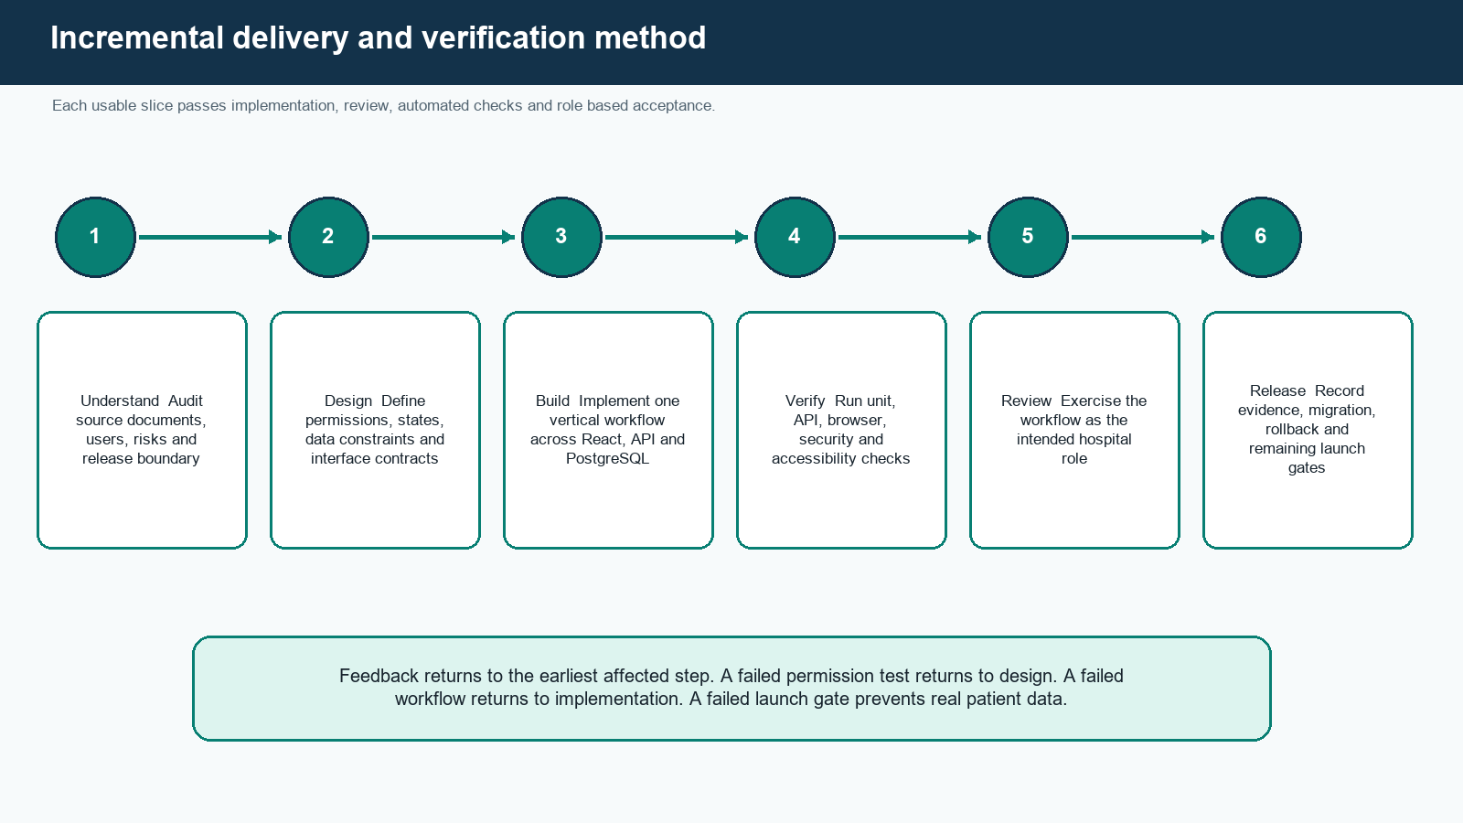
Figure 1.1: Incremental delivery and verification method
The method kept documentation beside the code. Requirements, implementation decisions, workflow states, release gates, defects, tests, production procedures, the adaptive mechanism, and the assistant boundary each have a maintained Markdown record. A change to a public state, permission, API, or operational procedure requires the matching documentation and regression test in the same revision.

1.6 Project Outcome
The outcome is a working local production candidate with a same origin React interface, Django API, PostgreSQL database, notification worker, Caddy gateway, reproducible container definitions, synthetic demonstration records, and repository based quality checks. Four role workspaces and the public doctor directory are usable. The queue estimate and assistant are implemented with conservative safety boundaries. The repository includes deployment, backup, restoration, monitoring, rollback, testing, and incident procedures.
The outcome is not represented as a live clinical system. External staging procurement, final hospital branding, current legal review, approved privacy and retention text, named staff enrollment, signed hospital UAT, production SMTP, off host recovery proof, and a controlled department pilot remain mandatory. This distinction is important because passing local software tests does not grant organisational authority to collect real patient data.

1.7 Organization of the Report
Chapter 2 reviews scheduling, attendance, self service access, queue systems, related products, and the gap addressed by this project. Chapter 3 presents stakeholders, requirements, architecture, data design, workflows, API contracts, security, user experience, the adaptive mechanism, and the assistant design. Chapter 4 explains the implementation, interfaces, test evidence, performance evidence, and results. Chapter 5 maps standards, professional responsibilities, project management, complex engineering problems, knowledge profiles, and activities. Chapter 6 concludes the work, states its limitations honestly, and identifies future development. Appendices provide the API inventory, test catalogue, deployment checklist, demonstration guide, and requirement traceability.

CHAPTER 2

BACKGROUND
This chapter establishes the scheduling and patient flow background, reviews verifiable literature and comparable systems, and explains the gap between a general appointment portal and the proposed operational pilot.

2.1 Domain Background
Appointment scheduling allocates limited provider time among patients whose arrival and service duration are uncertain. A slot is therefore both a promise to a patient and a capacity reservation for a hospital. Queue management begins when the patient reaches the service location. The appointment order, actual arrival, late attendance, walk ins, temporary deferral, doctor availability, and variable service time can all change the observed wait. These two problems are related but should not be represented by one overloaded status field.
The implemented model separates appointment state from queue state. An appointment may be confirmed while its patient has not checked in. Check in creates one queue ticket with a public token. The appointment later becomes completed or no show when the service path reaches a terminal result. This separation makes reports and permissions more precise. It also lets a patient leave the queue without silently deleting the original appointment history.
A hospital information service also has to manage identity, accountability, and recovery. The WHO global digital health strategy emphasises coordinated and sustainable digital health rather than technology in isolation [17]. For this project, sustainability means a small number of understandable services, a supported database, reproducible images, documented recovery, and controls that a small operational team can actually maintain.

2.2 Literature Review
The review concentrated on outpatient scheduling, wait reduction, nonattendance, reminders, and self scheduling because these topics directly influence the project. No paper was used to justify clinical prioritisation. The Adaptive Arrival Window is an engineering design for operational communication and requires evaluation against real pilot data before effectiveness can be claimed.
Table 2.1: Summary of literature reviewed
Author | Year | Focus | Relevance to this project
Cayirli and Veral [1] | 2003 | Review of outpatient scheduling literature | Classified appointment system decisions and sources of variability; established that scheduling performance depends on interacting design choices.
Cayirli, Veral and Rosen [2] | 2006 | Simulation study of ambulatory scheduling | Compared appointment rules and showed the importance of matching schedule design to the operating environment.
Gupta and Denton [3] | 2008 | Review and research agenda | Connected access, patient preferences, provider constraints and uncertainty; identified practical modelling challenges.
Ahmadi-Javid et al. [4] | 2017 | Systematic review of optimisation studies | Organised outpatient appointment optimisation research and highlighted assumptions that can limit practical transfer.
Dantas et al. [5] | 2018 | Systematic review of no shows | Reviewed causes and methods around nonattendance, supporting explicit cancellation, reminder and no show handling.
Rivas [6] | 2020 | Synthesis of advanced access evidence | Reported that access interventions can improve some operational outcomes while results depend on context.
Ansell et al. [7] | 2017 | Systematic review of wait reduction | Found multiple patient centred interventions, including open access, but did not establish one universal design.
McLean et al. [8] | 2016 | Reminder evidence synthesis | Showed reminders are useful but operate through context, information quality and patient ability to respond.
Zhao et al. [9] | 2017 | Meta analysis of digital notifications | Evaluated electronic notifications for appointment attendance and informed the minimal notification design.
Ahmadi et al. [10] | 2020 | Systematic review of no show prediction | Mapped prediction methods and limitations; reinforced the decision not to automate patient priority in this pilot.
Woodcock et al. [11] | 2022 | Review of automated self scheduling | Identified organisational, workflow, usability and integration factors beyond simply placing a calendar online.

Three conclusions shaped the design. First, no appointment rule is universally best because demand, service variation, capacity, and patient behaviour differ. Second, reminders and self service access help only when the underlying records and workflow are reliable. Third, predictive work must be evaluated carefully and should not be confused with clinical judgment. The proposed estimator therefore uses a transparent median based calculation, shows uncertainty and confidence, preserves first in first out order, and allows an auditable staff override rather than a hidden ranking.

2.3 Similar Applications
Five established product families were reviewed from their official public descriptions. Their inclusion does not imply access to proprietary architecture, security controls, or measured outcomes. The comparison records visible or documented capabilities only.
Table 2.2: Public capability comparison
Capability | Practo [12] | Qminder [13] | Doctolib [14] | Qmatic [15] | Epic MyChart [16] | Proposed
Doctor discovery and appointment request | Yes | Limited | Yes | No | No | Yes
Patient self service portal | Yes | No | Yes | Limited | Limited | Yes
Reception or kiosk queue | No | Yes | No | Yes | Yes | Yes
Privacy safe patient queue token | Not established | Yes | Not established | Yes | Yes | Yes
Live operational wait information | Limited | Yes | Limited | Yes | Yes | Yes
Role aware live help assistant | Not established | Not established | Not established | Not established | Not established | Yes
Transparent adaptive arrival range | Not established | Not established | Not established | Not established | Not established | Yes
Deployment and recovery evidence in project scope | Not public | Not public | Not public | Not public | Not public | Yes

Practo and Doctolib demonstrate doctor discovery and online booking. Qminder and Qmatic focus more directly on arrival and patient flow. MyChart represents a broad patient portal around a larger clinical platform. The proposed system does not try to reproduce those product ecosystems. Its value is the coherent implementation of a small hospital workflow, visible integrity controls, auditable queue decisions, and a deployment package that can be examined academically.

2.4 Gap Analysis
Table 2.3: Observed gaps and design response
Gap | Consequence | Project response
Appointment calendar separated from reception queue | Patients receive a booking time but cannot understand actual progress | Join booking and check in through a separate queue ticket and privacy safe snapshot
Public screens expose names or identifiable queue details | Waiting patients can learn another person's visit pattern | Show tokens only and filter every response by role and ownership
Repeated clicks and competing staff actions are treated as interface issues | Double booking, double check in, duplicate payment or two active patients | Enforce idempotency, row locks, constraints and legal state transitions in the API
Wait estimates appear as unexplained exact numbers | False certainty and difficult operational review | Return a bounded range, confidence, sample count, calculation version and freshness
Generic chatbot receives broad database access | Cross role disclosure, unsafe advice and actions without accountability | Build allowlisted role context, read only tools, clinical refusal and deterministic fallback
A classroom deployment ends at docker compose up | No recovery, rollback, monitoring or authority for real data | Define launch gates, role separation, backups, restore tests, alerts and incident procedures

2.5 Novelty Boundary
The project does not claim that queues, median service estimates, reminders, language models, or role based access were invented here. Its novel contribution is the implementation combination: a first in first out hospital queue, a transparent adaptive arrival range, freshness and confidence indicators, recorded fairness overrides, a role aware read only assistant, and transactional audit evidence in one small hospital production candidate. The contribution is described as original project engineering, not as a worldwide first. A real pilot must collect error, interval coverage, override, and user acceptance evidence before any stronger effectiveness claim is made.

2.6 Summary
The background review shows that scheduling and attendance are context dependent operational problems. Comparable products validate demand for digital booking and queue communication but do not remove the need for a careful local design. The identified gap leads directly to the requirements and architecture in Chapter 3.

CHAPTER 3

REQUIREMENT ANALYSIS AND DESIGN SPECIFICATION
This chapter converts the problem into verifiable functional and quality requirements. It then presents the role model, architecture, records, interfaces, workflows, security controls, adaptive estimate, assistant, alternatives, and project plan.

3.1 Stakeholders and Operating Assumptions
Table 3.1: Stakeholders and principal needs
Stakeholder | Principal need
Patient | Find a doctor, book, reschedule or cancel, understand queue progress, receive notices, control own profile
Doctor | See assigned schedule and minimum patient identity, operate own queue, understand workload
Receptionist | Register and find patients, prevent duplicates, manage appointments, check in, handle walk ins, queue and onsite payment
Administrator | Manage staff, hospital directory, schedules, settings, reports, notifications and audit evidence
Hospital operations owner | Approve workflow, data policy, support, downtime, incident and launch decisions
Deployment operator | Maintain environment, secrets, images, migrations, monitoring, backup and recovery without reading patient records unnecessarily
Academic examiner | Evaluate requirements, design choices, implementation evidence, limitations and professional responsibility

The operating assumptions are one active hospital, Asia/Dhaka display time, BDT currency, email availability for self registering patients, invitation controlled staff identities, and onsite payments only. The service must remain useful when email is delayed and when the optional language provider is absent. The browser is untrusted. Interface visibility never replaces server authorization.

3.2 Role and System Context
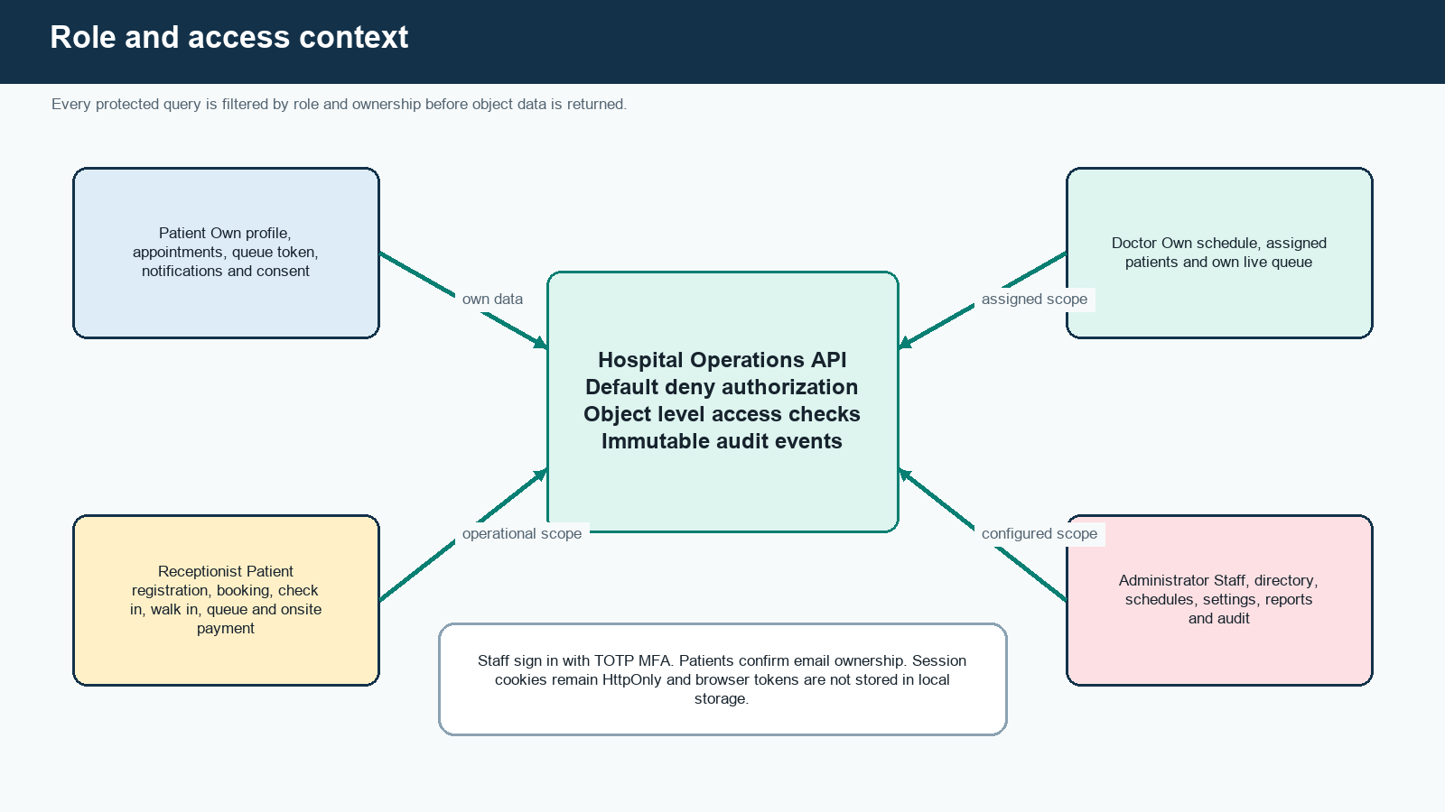
Figure 3.1: Role and access context
Patients can see only their own claimed profile, appointments, queue ticket, payment summary, notifications, and consent. Doctors can see only their linked schedule and the minimum patient identity associated with their appointments and queue. Receptionists receive operational access needed for registration and flow, but cannot create privileged staff. Administrators configure the service and review audit records. Staff actions require completed TOTP MFA. Querysets are filtered before object lookup so changing a UUID cannot turn a forbidden object into a disclosed object.

3.3 Functional Requirements
Table 3.2: Functional requirements
ID | Function | Verifiable requirement
FR01 | Public directory | Anyone can view active hospital details, departments, doctors and safe future availability.
FR02 | Patient registration | A patient accepts the active privacy notice, verifies email and receives one unique MRN.
FR03 | Assisted registration | Reception can create an unclaimed profile and send a single use claim invitation without inventing an email.
FR04 | Duplicate warning | Reception receives a review warning for matching identity fields; the system never merges automatically.
FR05 | Staff invitation | An administrator invites a named staff member to one approved role with an expiring single use token.
FR06 | Staff MFA | A staff session remains pending until a valid, nonreplayed TOTP is confirmed.
FR07 | Directory management | Administration creates, edits, orders and deactivates departments, locations, chambers and doctors.
FR08 | Schedule management | Administration creates effective schedules and dated exceptions while rejecting unsafe overlaps.
FR09 | Availability | The API computes slots from schedule, exception, local time and confirmed capacity.
FR10 | Booking | A verified patient or reception user reserves eligible capacity within one transaction.
FR11 | Rescheduling | An eligible confirmed appointment moves old and new capacity atomically and records both values.
FR12 | Cancellation | An eligible actor supplies the required reason and releases future capacity exactly once.
FR13 | Check in | Reception creates one queue ticket and final token for an eligible appointment on its service date.
FR14 | Walk in | Reception registers or selects a patient, creates a same day appointment, and checks in through one controlled workflow.
FR15 | Queue operation | Authorised staff call next, start, defer, restore, complete, no show or cancel through legal transitions.
FR16 | Patient queue | A patient sees own token, served token, wait range, arrival guidance, confidence and update time without names.
FR17 | Payment | Reception records unpaid, paid onsite, waived or refunded state in integer BDT minor units with history.
FR18 | Notification | A committed event can create in application and minimal email notifications through an outbox.
FR19 | Audit | Security and business events retain actor, action, subject, reason, request identifier and safe changes.
FR20 | Assistant | An authenticated role asks system questions and receives guidance plus only allowlisted live facts.
FR21 | Failure recovery | Email and provider failure do not roll back business records; retries and fallback remain bounded.
FR22 | Hospital settings | Administration configures development branding, contact values, timezone display and current privacy notice.

3.4 Nonfunctional Requirements
Table 3.3: Nonfunctional requirements
ID | Quality | Acceptance statement
NFR01 | Security | Apply OWASP ASVS Level 2 controls where applicable; no unresolved critical or high finding at launch.
NFR02 | Privacy | Minimise data by role, channel, URL and log; never show another patient name in queue progress.
NFR03 | Integrity | No slot over capacity, duplicate ticket, duplicate MRN, duplicate active service or illegal terminal transition.
NFR04 | Availability | Initial service target is 99.5 percent monthly availability after production monitoring begins.
NFR05 | Performance | Production sized staging target is read p95 below 500 ms, write p95 below 800 ms and queue freshness within 15 seconds.
NFR06 | Capacity | Support the agreed pilot of 30 doctors, 500 daily appointments and 50 concurrent users.
NFR07 | Accessibility | Target WCAG 2.2 AA with keyboard, focus, labels, reflow, contrast, status announcements and no color only meaning.
NFR08 | Recovery | Encrypted separate backup copies target a one hour RPO and four hour RTO; clean restore is rehearsed.
NFR09 | Auditability | Material state change and override evidence is append only through the application and correlated by request ID.
NFR10 | Maintainability | Exact dependencies, small modules, explicit contracts, migrations, tests, human readable commits and operational documentation.
NFR11 | Compatibility | Use current Chromium for automated release evidence and complete the documented wider browser checks before real data.
NFR12 | Safety | No diagnosis, medical advice, automatic triage, hidden queue priority, card processing or unsupported interoperability claim.

3.5 Architecture
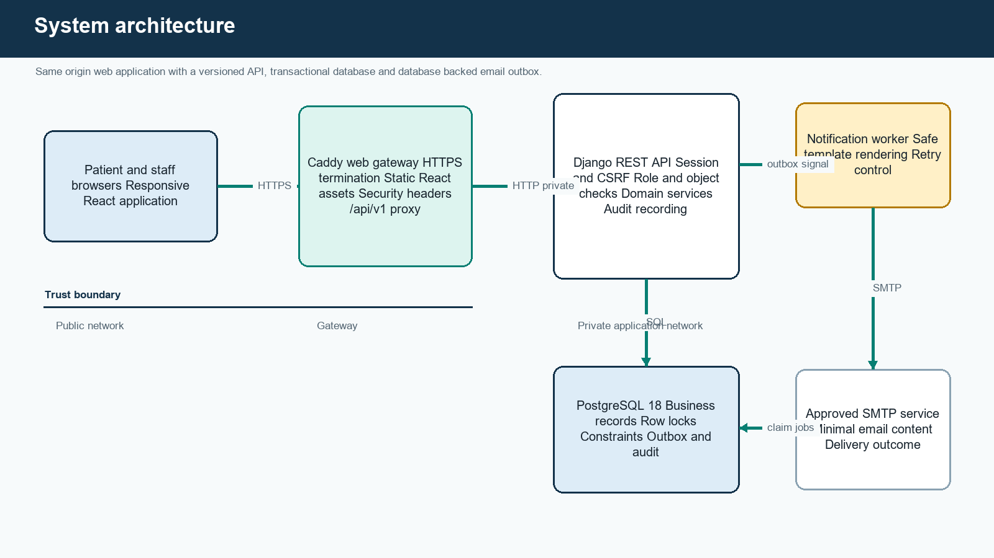
Figure 3.2: System architecture
The browser and API share one origin. Caddy serves the immutable React build and proxies only the versioned API path to Django. This removes a separate cross origin token architecture and allows Django sessions and CSRF protection to operate normally. The React application performs presentation and interaction; it does not enforce final authority. Django serializers validate shape, permission classes establish the role boundary, views locate role filtered records, and domain services execute state changes inside transactions.
PostgreSQL is the single source of operational truth. It stores business entities, state history, queue estimates, audit events, idempotency outcomes, notification jobs, and login audit. The notification worker claims committed outbox rows and contacts SMTP independently. An email failure therefore changes the delivery record but cannot erase a successful appointment. Conditional queue reads use ETag and If-None-Match so unchanged snapshots can return without a repeated response body.
The architecture intentionally omits Redis and WebSockets. Ten second polling on an active queue page and 30 second polling in the background meet the pilot freshness design with fewer moving parts. A snapshot becomes visibly stale after 30 seconds without success. This is an explicit scale tradeoff, not a claim that polling is always superior.

3.6 Data Model and Integrity
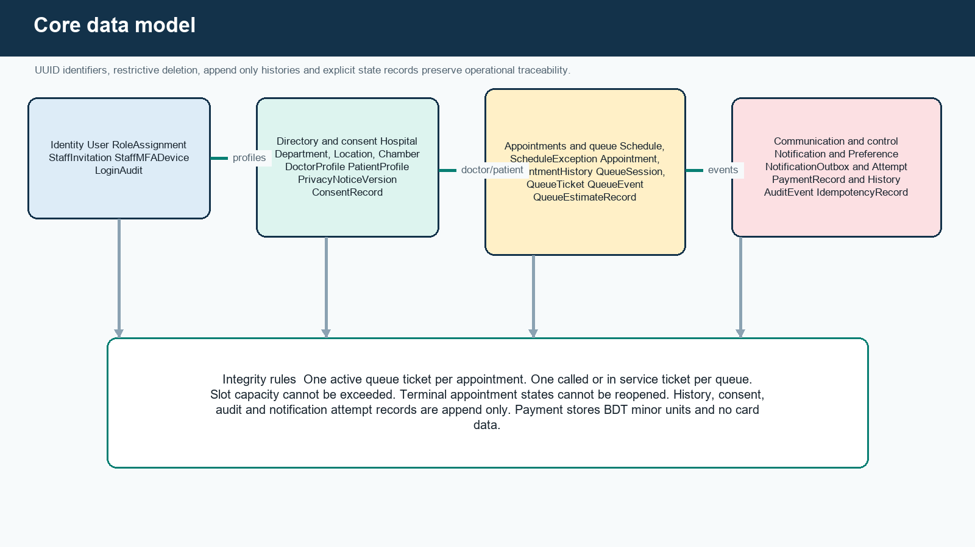
Figure 3.3: Core data model
Table 3.4: Core data dictionary
Record group | Purpose | Important invariant
User, RoleAssignment | Authentication identity and one or more explicit application roles | Unique normalised email; protected role grant
StaffInvitation, StaffMFADevice, LoginAudit | Staff onboarding, encrypted TOTP material and authentication evidence | Single use invitation; no raw recovery code in storage
Hospital, Department, Location, Chamber | Configurable organisation and service locations | One active hospital for pilot; unique local codes
DoctorProfile, PatientProfile | Role specific directory and patient identity | UUID public IDs; unique doctor code and generated MRN
PrivacyNoticeVersion, ConsentRecord | Exact notice text and patient decision history | Append only consent tied to immutable notice version
Schedule, ScheduleException | Recurring hours, capacity and dated closure or replacement | Overlap validation; referenced structural schedule fields immutable
Appointment, AppointmentHistory | Current booking and every material appointment change | Capacity transaction; four exact appointment states
QueueSession, QueueTicket, QueueEvent | Daily service order, current token and transition evidence | One active ticket per appointment and one active service position
QueueEstimateRecord | Calculation inputs and output used for one patient snapshot | Append only version, sample and uncertainty evidence
PaymentRecord, PaymentHistory | Onsite BDT status and corrections | Integer minor units; no card or bank credential fields
Notification, NotificationOutbox, NotificationAttempt | In app messages and reliable email delivery | Business commit separated from delivery retry
AuditEvent, IdempotencyRecord, RateLimitBucket | Traceability, repeated write result and shared abuse control | Safe structured data and bounded retention

Every externally addressable business record uses a UUID. Sequential database keys, where present internally, do not become object authority. Timestamps are stored in UTC and displayed in Asia/Dhaka. Money is stored as integer BDT minor units. Patients, doctors, schedules, and referenced configuration are deactivated or superseded rather than silently deleted. Restrictive foreign keys keep historical records from becoming detached.

3.7 Appointment and Queue State Design
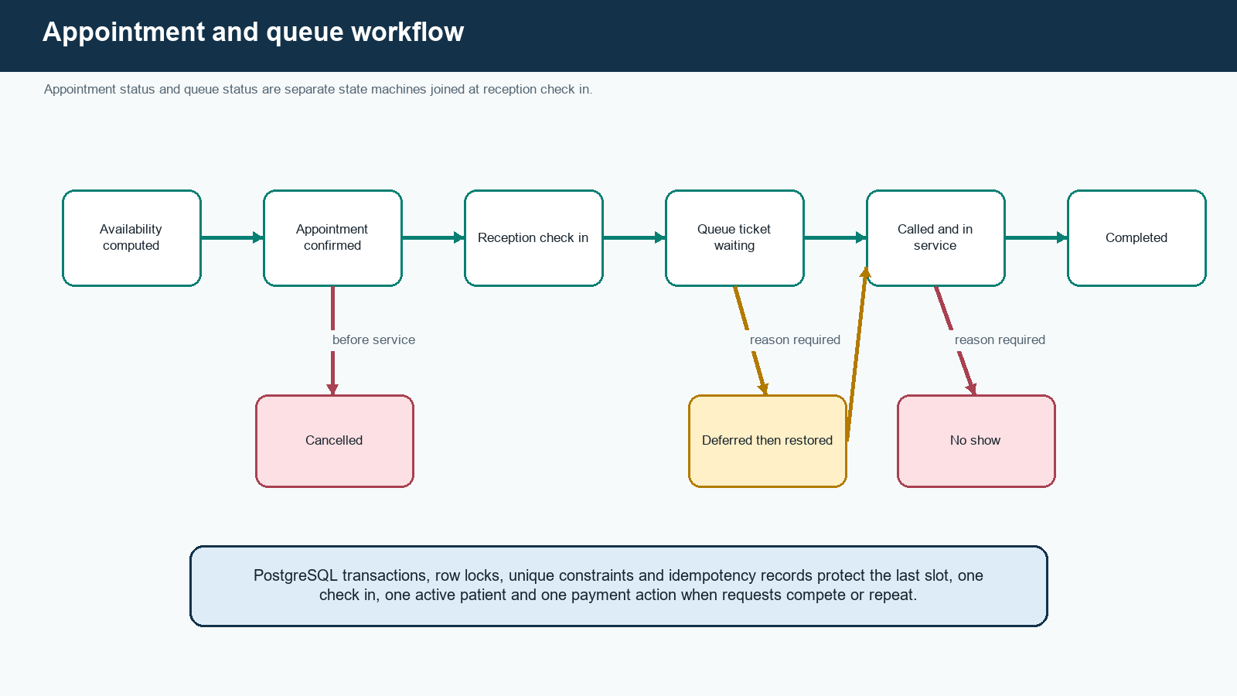
Figure 3.4: Appointment and queue workflow
Appointment states are confirmed, cancelled, completed, and no_show. Queue states are waiting, called, in_service, deferred, completed, no_show, and cancelled. Cancelled, completed, and no show appointments are terminal. Queue defer and restore are explicit because temporarily passing a patient should not be disguised as cancellation. Every override requires a reason and records the previous state, new state, actor, time, and request identifier.
A write request carries an Idempotency-Key. The server associates its digest with the authenticated actor, route scope, and request digest. An exact retry receives the stored outcome. Reusing the key with a different body is rejected. For competing actions, PostgreSQL row locks serialize the schedule, appointment, queue session, or ticket that owns the invariant. Database constraints remain the final protection if application checks race. PostgreSQL documentation distinguishes row level locking and constraint enforcement, which are both used here [23], [24].

3.8 API Contract
Table 3.5: Versioned API groups
Area | Path | Responsibility
Authentication | /api/v1/auth/ | CSRF, session, login, MFA, registration, verification, reset, invitation and claim
Public directory | /api/v1/public/ | Hospital, departments, doctors and doctor availability
Patient self service | /api/v1/me/ and /appointments/ | Own profile, consent, appointments, queue and notifications
Reception | /api/v1/reception/ | Patient search, duplicate check, assisted registration, check in and walk in
Queue | /api/v1/queues/ and /queue-tickets/ | Conditional snapshot and controlled state actions
Payments | /api/v1/appointments/{id}/payment/ | Onsite state, corrections and history
Administration | /api/v1/admin/ | Staff, settings, privacy notices, directory, schedules, outbox and audit
Assistant | /api/v1/assistant/chat/ | Authenticated role guidance and read only live context
Health | /api/v1/health/ | Liveness and configuration plus database readiness

Successful resources use stable JSON representations. Errors use status, code, title, detail, field_errors, and request_id. Input serializers reject unknown fields on sensitive workflows so a client cannot mass assign role, ownership, state, amount, or audit values. Protected responses use private no store caching where appropriate. Queue snapshots alone expose an ETag suitable for conditional refresh.

3.9 Adaptive Arrival Window
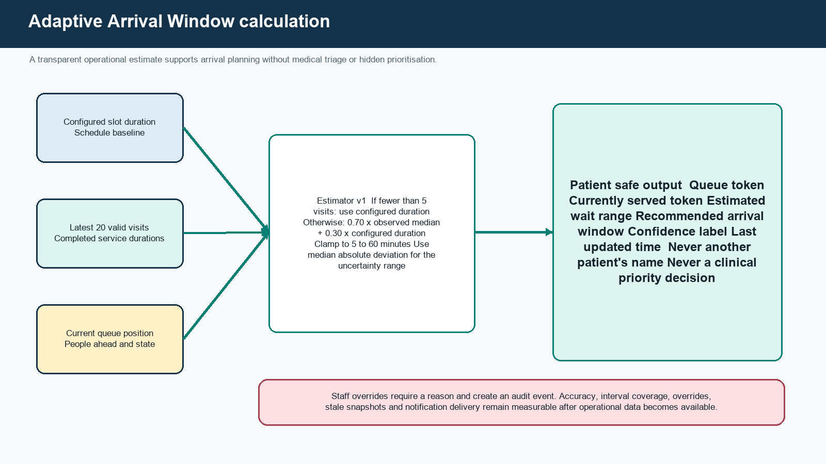
Figure 3.5: Adaptive Arrival Window calculation
The live queue remains first in first out by valid check in order. The mechanism never interprets symptoms, diagnoses urgency, or changes priority. Before a doctor has five valid completed visits, the configured schedule duration is used. From five observations onward, the service estimate is 70 percent of the median of the latest 20 valid completed durations plus 30 percent of the configured duration. The result is clamped between five and 60 minutes. Median absolute deviation describes observed variability when enough data exists; otherwise the response uses a deliberately wider fallback interval.
estimated_service = clamp(0.70 × median(recent_valid_durations) + 0.30 × configured_duration, 5, 60)
estimated_wait = people_ahead × estimated_service
arrival_window = bounded range derived from wait and observed or fallback uncertainty
The response contains token, currently served token, people ahead, lower and upper wait bounds, recommended return or arrival window, confidence label, sample count, calculation version, and last update time. A stored QueueEstimateRecord makes the shown result explainable later. Accuracy is measured as absolute and median absolute error, interval coverage, override rate, stale snapshot rate, and sample count by doctor. Those metrics cannot be reported honestly until a real controlled pilot produces representative durations.

3.10 Role Aware Assistant
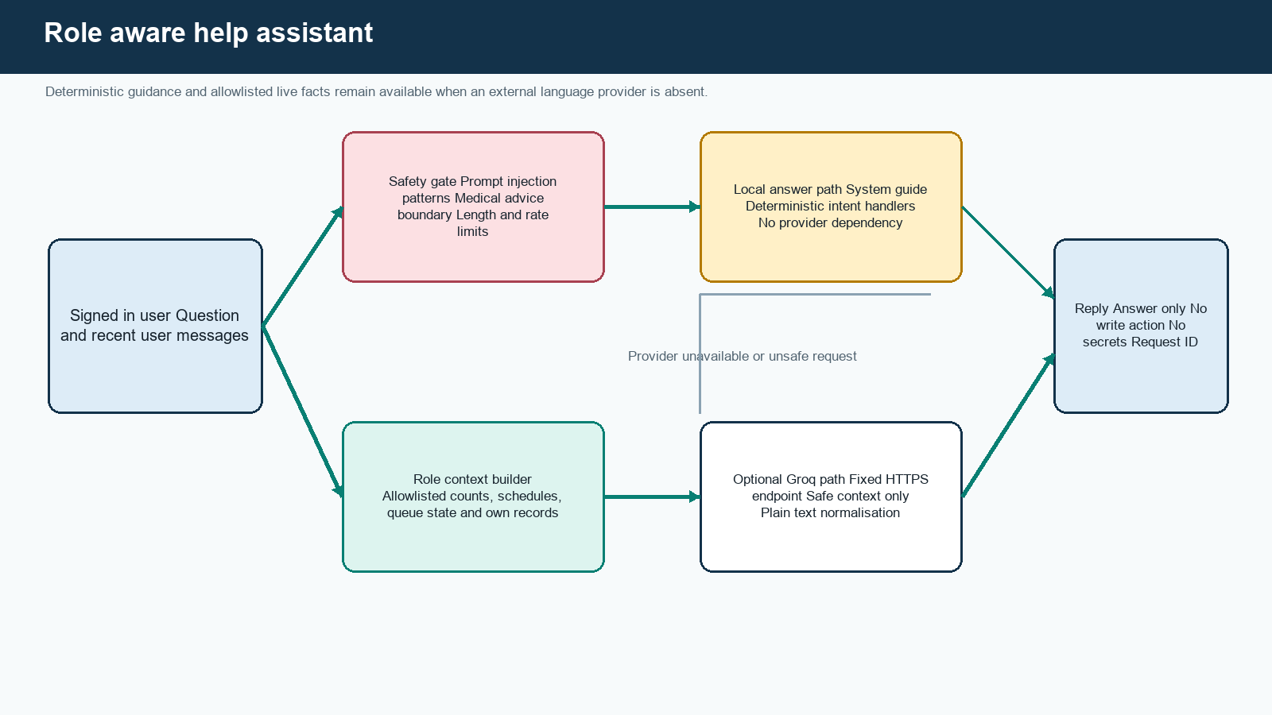
Figure 3.6: Role aware help assistant
The assistant is an authenticated, read only help layer. It answers navigation and workflow questions for every role. A patient can ask how to book, whether a selected doctor has future capacity, or what the patient's own queue status means. A doctor can ask which scheduled working day has lower current appointment pressure. Reception and administration can request aggregate operational totals. The server derives role from the session rather than from a client supplied role name.
Live facts are built by allowlisted query functions. A patient context contains only that patient's records. A doctor context starts from the linked DoctorProfile. Reception and administrator context provides approved counts without patient names or identifiers. The client never sends raw database context to the provider. Questions that request clinical advice, medical urgency, hidden instructions, credentials, another person's data, or unsupported actions are refused or answered through the safe local path.
The deterministic path covers essential system guidance and remains the default reliability layer. If a replacement Groq key is configured by the authorised operator, the optional provider receives only the system guide, safe role context, the question, and a bounded recent user history through a fixed HTTPS endpoint. Timeouts and provider errors return to local guidance. Output is normalised to plain text because the panel does not render arbitrary Markdown. The assistant cannot book, cancel, change a queue, edit a patient, or record a payment. Groq's API documentation is used only for the optional integration contract [27].

3.11 Security and Privacy Design
Table 3.6: Security and privacy controls
Area | Implemented design
Authentication | Django password hashing, email ownership for patients, invitation only staff, TOTP MFA, replay control, lockout and bounded sessions
Browser session | Secure HttpOnly cookie in production, SameSite policy, CSRF token, trusted origin checks and no bearer token in local storage
Authorization | Default deny, role permission, filtered queryset, object ownership and service level invariant checks
Data minimisation | Queue tokens instead of names, minimal emails, no clinical data, no card fields, safe logs and generic public responses
Integrity | Transactions, row locks, unique and check constraints, idempotency and append only state history
Secrets | External environment files, independent values, stable MFA encryption key, no repository key and no secret in screenshots
Runtime | Nonroot containers, read only filesystems, dropped capabilities, private database network and narrow public ports
Supply chain | Exact lockfiles, immutable container references, dependency review, source scanning and secret scanning
Recovery | Encrypted backup, separate copy approval, restoration rehearsal, RPO, RTO, migration and rollback procedure
Accountability | Login audit, business audit, consent versions, history records, notification attempts and request correlation

The control baseline uses applicable OWASP ASVS 5.0 Level 2 verification items [20], Django security guidance [22], and secure development practices from NIST SP 800-218 [18]. This is a mapped engineering baseline, not a certification. Bangladesh legal applicability, retention, data location, controller responsibilities, and hospital policy still require qualified review against the current official instruments before real data [25].

3.12 User Interface and Accessibility Design
The interface uses a quiet hospital palette, clear page titles, familiar form labels, status text in addition to colour, visible keyboard focus, responsive navigation, and action placement close to the relevant record. Patient pages emphasise the next decision. Reception pages place search, appointment action, and queue action in operational order. Doctor pages minimise navigation around the current queue. Administrator pages separate configuration resources instead of presenting one crowded dashboard.
Loading, empty, success, validation error, server failure, offline queue, reconnecting, stale data, destructive confirmation, and permission denial are designed states. Queue changes use screen reader announcements without repeating another patient identity. The target is WCAG 2.2 AA [19]. Automated checks support, but do not replace, keyboard and screen reader review with hospital users.

3.13 Alternatives Considered
Table 3.7: Design alternatives
Decision | Alternative | Selected | Reason
Database | MySQL or SQLite | PostgreSQL 18 | One supported database across environments, strong constraints, transactional row locking and operational consistency
Authentication | Browser stored JWT | Django session and CSRF | Same origin deployment reduces token exposure and simplifies invalidation
Queue updates | WebSockets with Redis | Conditional HTTP polling | Meets 50 user pilot freshness with fewer services and easier recovery
Background work | General message broker | Database outbox worker | Keeps appointment commit and notification intent atomic without another datastore
Wait estimate | Mean or opaque prediction model | Median blend plus uncertainty | Robust to outliers, explainable, bounded and testable with little initial data
Assistant | Provider only chatbot with broad tools | Local guidance plus optional provider | Essential help survives provider failure and live data access stays allowlisted
Frontend | Server rendered templates | React application | Supports distinct workspaces, polling state and responsive interaction while retaining one origin

3.14 Project Plan and Task Allocation
Table 3.8: Project activity plan
Work package | Main work | Output
Planning and audit | Requirements, scope, risks, documents and repository controls | Requirement traceability and approved implementation boundary
Foundation | React, Django, PostgreSQL, containers, identity, roles and shared UI | Healthy same origin application with protected sessions
Directory and scheduling | Hospital configuration, doctors, locations, schedules and capacity | Public discovery and administrable availability
Appointment operations | Patient identity, booking, rescheduling, cancellation, walk ins and check in | Transactional appointment workflow
Queue and communication | Queue states, estimator, payment, notifications, audit and assistant | Complete outpatient operational path
Verification | Unit, API, browser, concurrency, load, security, dependency and recovery checks | Recorded evidence and defect correction
Delivery | Screenshots, report, staging instructions, release and launch gate review | Submission package and production candidate

Md. Sobuj Mia concentrated on requirement consolidation, backend domain design, database integrity, deployment evidence, and report traceability. Md. Ismail Hossain concentrated on interface implementation, role journeys, synthetic data, browser verification, and evidence capture. Both members reviewed security boundaries, executed manual role walkthroughs, corrected integration defects, and prepared the final presentation. Git history and automated checks remain the technical evidence; this allocation describes responsibility rather than claiming that either member worked in isolation.

3.15 Summary
The design treats authorization, state, concurrency, privacy, and recovery as core functions. The selected architecture remains small enough for the stated pilot but includes the controls needed to test it seriously. Chapter 4 shows how these decisions were implemented and verified.

CHAPTER 4

IMPLEMENTATION AND RESULTS
This chapter describes the implemented environment and modules, shows the working interfaces, and reports the verified software quality evidence with clear limits on what local testing can prove.

4.1 Development and Runtime Environment
Table 4.1: Implementation environment
Layer | Implemented technology
Frontend | React 19.2.8, React Router 7.18.2, Vite 8.2.1, Tailwind CSS 4.3.3, JavaScript
Backend | Python 3.14.7, Django 5.2 LTS, Django REST Framework, Gunicorn
Database | PostgreSQL 18.6 in local, test, staging and production definitions
Gateway | Caddy serving built assets and proxying /api/v1 on the same origin
Containers | Docker Compose with nonroot runtime, read only filesystems and private networks where applicable
Testing | Django TestCase and transaction tests, Coverage.py, Vitest, Testing Library, Playwright Chromium, axe and k6
Security checks | Django deployment check, Bandit, Semgrep, dependency audit, container configuration and secret scan
Repository | Private GitHub repository with short lived branches, pull requests and required automated checks

Exact direct and transitive dependencies are committed in lockfiles. The development service supports live frontend work, while test and production definitions build immutable assets. The API and worker share the same backend image so they cannot silently drift. Migrations use a database owner account; the long running API uses a separate restricted runtime account in controlled environments.

4.2 Backend Implementation
The backend is organised into accounts, directory, operations, communications, help_assistant, and shared core modules. Accounts implements custom users, role assignment, invitations, patient and staff onboarding, MFA, account tokens, login audit, and session controls. Directory implements hospital configuration, departments, locations, chambers, doctor profiles, patient profiles, privacy notice versions, consent, duplicate warnings, and correction history. Operations contains schedules, appointments, queue sessions and tickets, estimates, payments, histories, dashboards, and service functions. Communications contains in application notifications and the email outbox. Core contains stable exceptions, permissions, middleware, throttling, audit, idempotency, logging, and health checks.
Views remain thin around serializer validation, role filtered lookup, and service invocation. Competing writes run in atomic blocks and acquire rows in a consistent order. For example, rescheduling locks the appointment and both schedule allocations before changing capacity. Call next locks the queue session before selecting an eligible waiting ticket. Append only database triggers protect histories and audit style records from ordinary update or delete operations even if future application code makes a mistake.

4.3 Frontend Implementation
The frontend uses route guards for usability, but relies on the API for authority. AuthContext retrieves the current server session, BrandContext retrieves safe hospital presentation values, and the API client obtains a CSRF token before state changing requests. Shared components implement panels, forms, status pills, dialogs, loading placeholders, feedback, pagination, and accessible focus behaviour. Each role has a separate layout and navigation set. Polling logic stops unnecessary foreground frequency when the page is in the background and marks stale data after failed refreshes.
The assistant is a global authenticated widget. It opens from every role workspace, uses role specific suggestions, labels whether an answer used live information, provides safe internal links returned by the server, and never renders arbitrary HTML. Conversation history is kept short in component state rather than written to browser storage.

4.4 Deployment Implementation
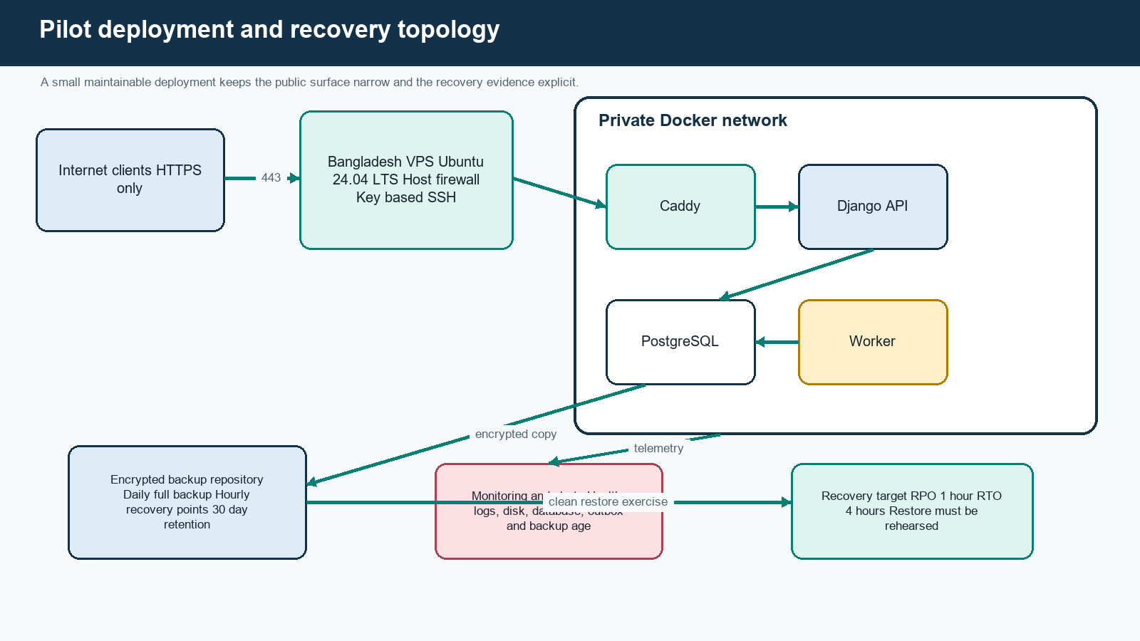
Figure 4.1: Pilot deployment and recovery topology
The planned pilot host has 4 vCPU, 8 GiB RAM, 160 GiB NVMe storage, Ubuntu 24.04 LTS, a Bangladesh location, key based SSH, and a firewall exposing only approved management access and HTTPS. PostgreSQL has no public port. Caddy applies HTTPS and response headers. Production secrets live outside Git in a protected environment file. Images are released by immutable digest through an approved environment.
Backup design uses pgBackRest with encrypted daily full backups and hourly recovery points on separately approved storage, retained for 30 days. Timers, backup age checks, clean restore instructions, and database reconciliation are included. A rollback distinguishes application rollback from incompatible schema reversal. When a safe reverse migration is unavailable, the documented decision is forward correction or restoration to a verified recovery point.

4.5 Implemented Interface Evidence
The following figures were captured from the running application with synthetic Bengali names. They demonstrate the implemented navigation and representative actions. No production identity, patient record, MFA secret, password, API key, or real email address appears in the evidence.
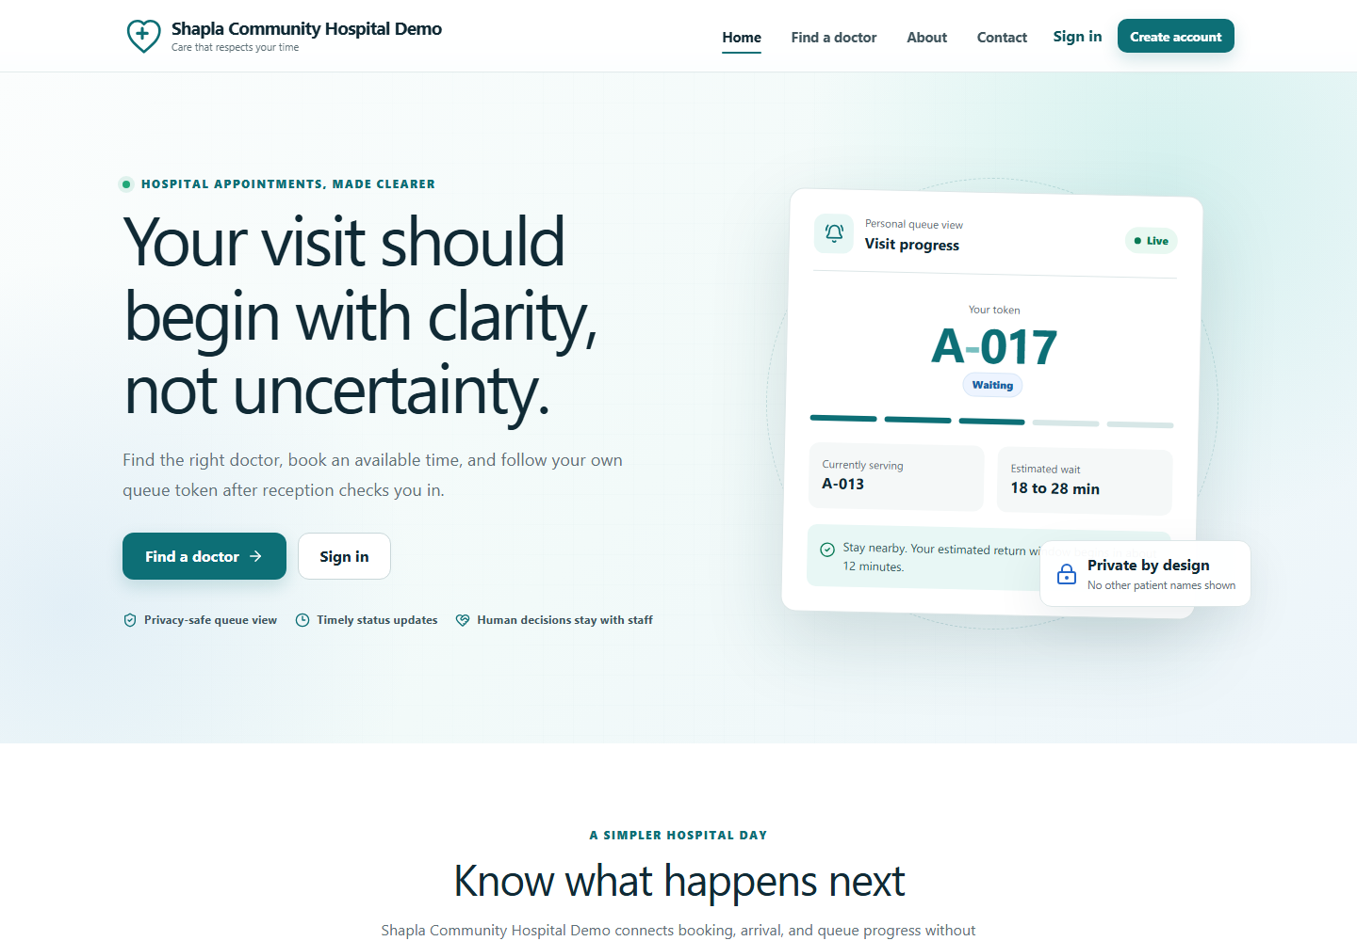
Figure 4.2: Public home page with hospital service entry points
Source: Synthetic demonstration data captured from the implemented local release candidate.
The public landing page introduces the service and keeps doctor discovery and account actions clear.
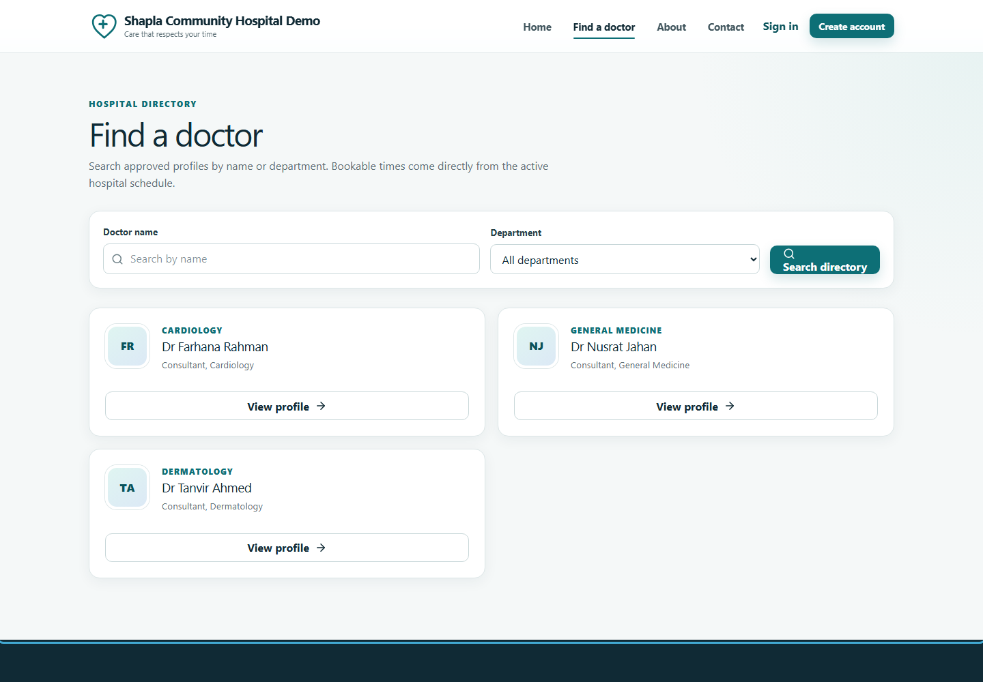
Figure 4.3: Public doctor directory
Source: Synthetic demonstration data captured from the implemented local release candidate.
The directory exposes approved professional data and links to safe availability without patient information.
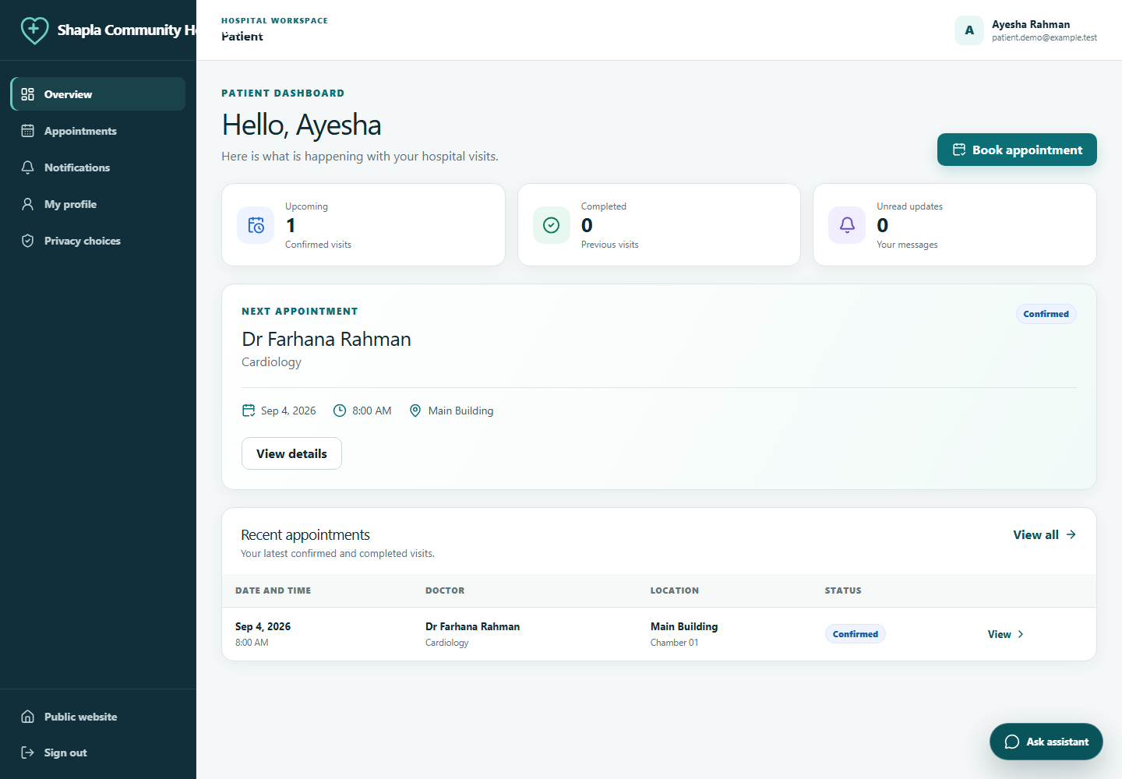
Figure 4.4: Patient dashboard
Source: Synthetic demonstration data captured from the implemented local release candidate.
The patient workspace prioritises the next appointment, notifications and personal actions.
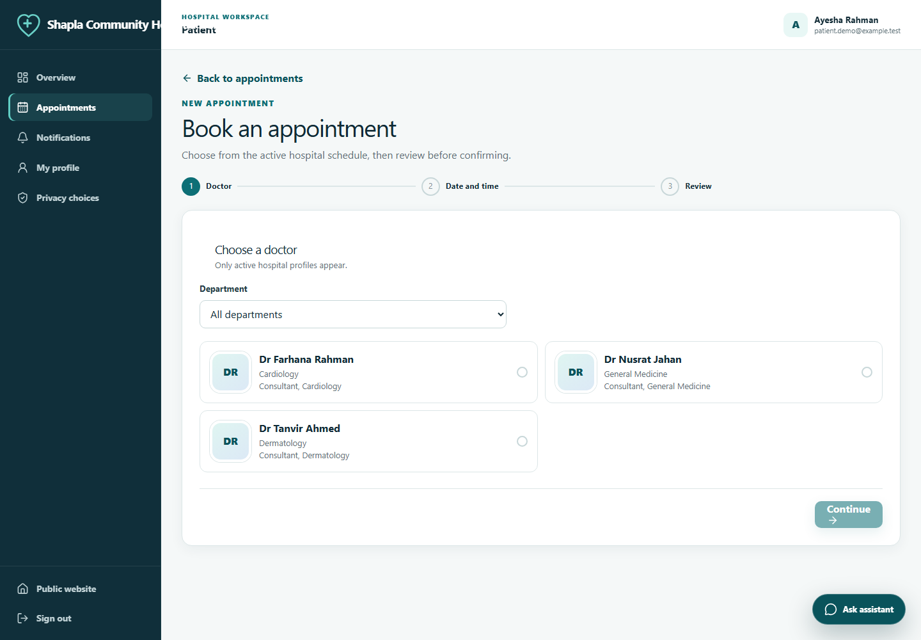
Figure 4.5: Appointment booking workflow
Source: Synthetic demonstration data captured from the implemented local release candidate.
Booking moves through doctor, date, slot and review data while the API retains final capacity authority.
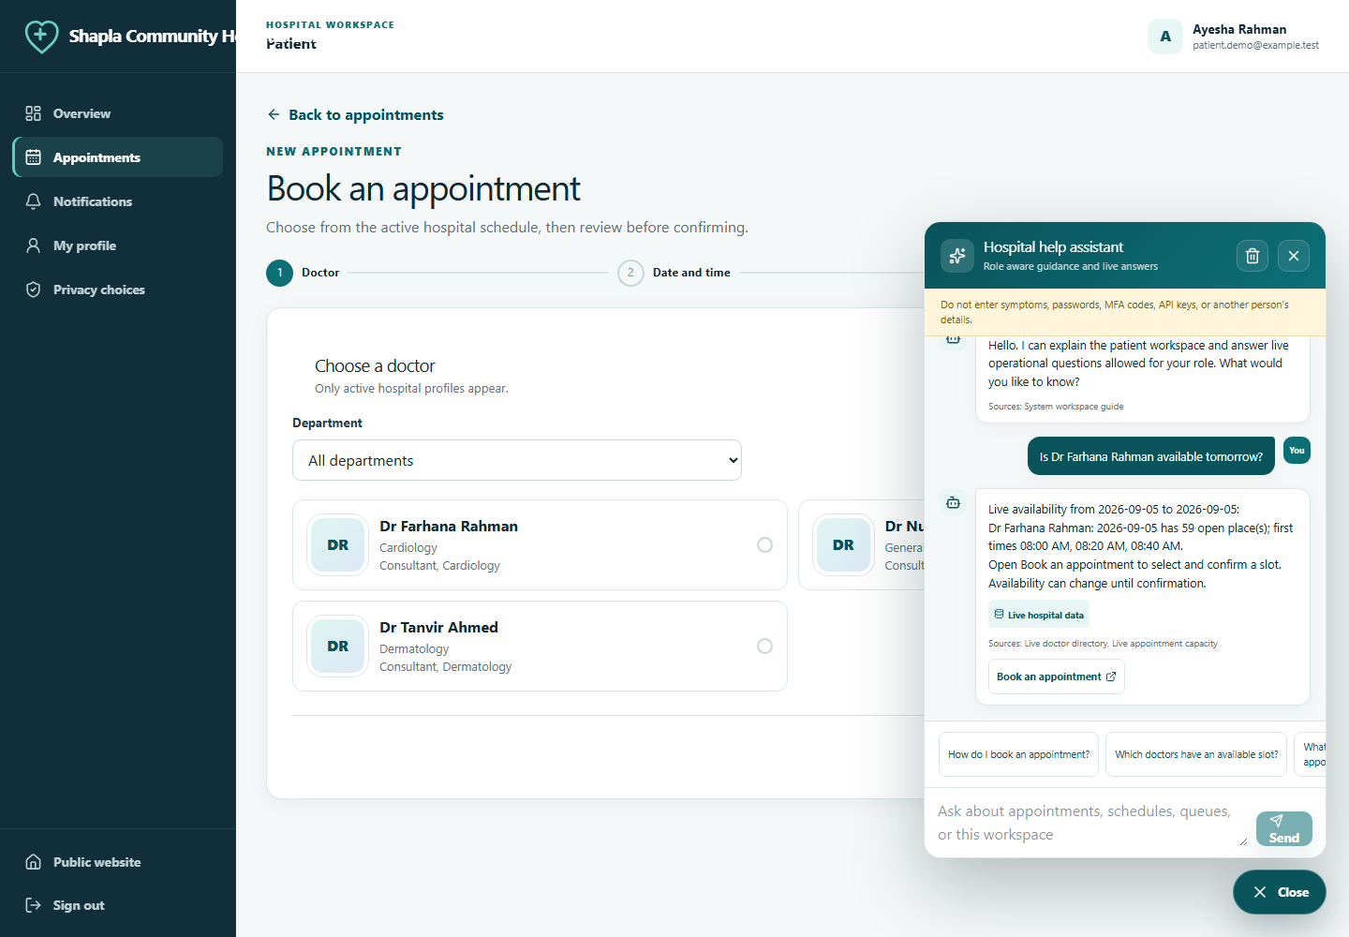
Figure 4.6: Patient assistant showing live availability
Source: Synthetic demonstration data captured from the implemented local release candidate.
The assistant reports safe schedule capacity and explains how to continue without creating an appointment itself.
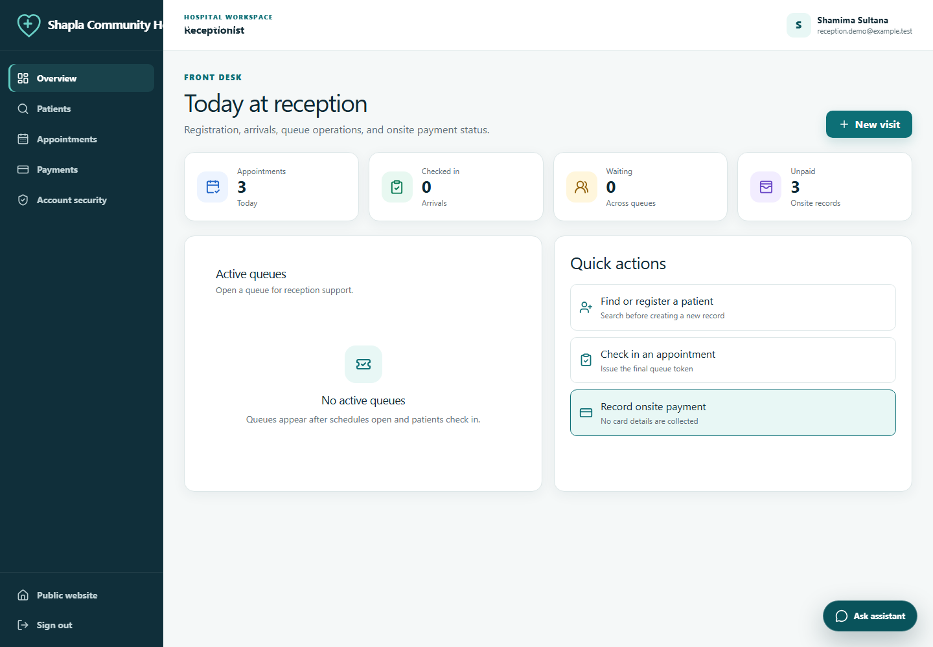
Figure 4.7: Reception dashboard
Source: Synthetic demonstration data captured from the implemented local release candidate.
Reception receives operational counts and direct access to patient, appointment and queue tasks.
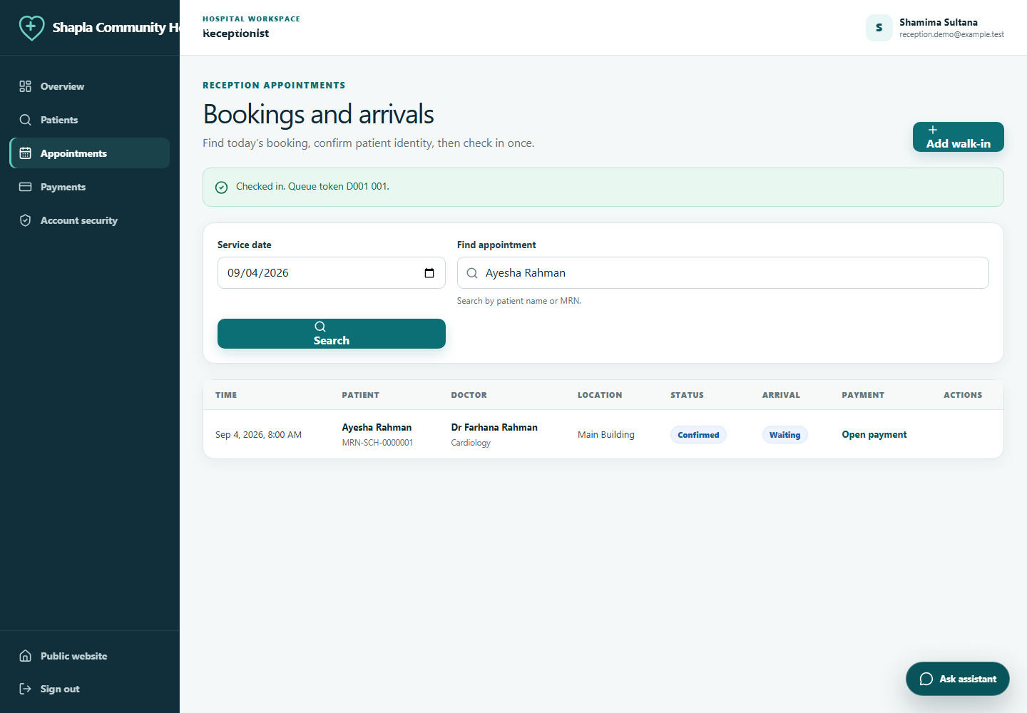
Figure 4.8: Reception view after appointment check in
Source: Synthetic demonstration data captured from the implemented local release candidate.
Successful check in produces a privacy safe token and one traceable queue ticket.
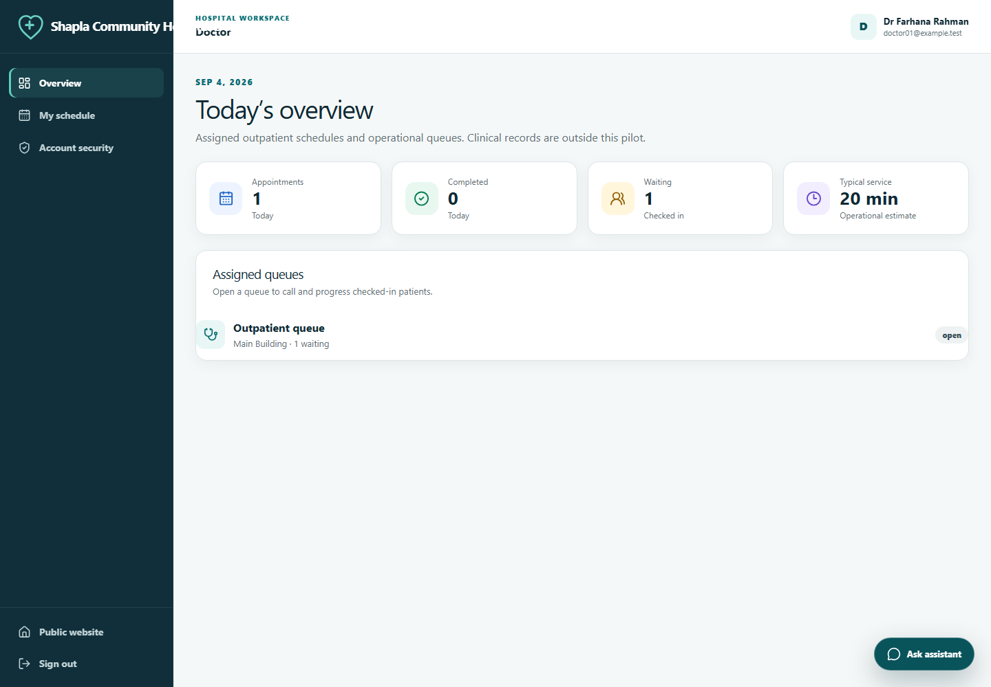
Figure 4.9: Doctor dashboard
Source: Synthetic demonstration data captured from the implemented local release candidate.
Doctors see their own service workload, schedule and queue entry points.
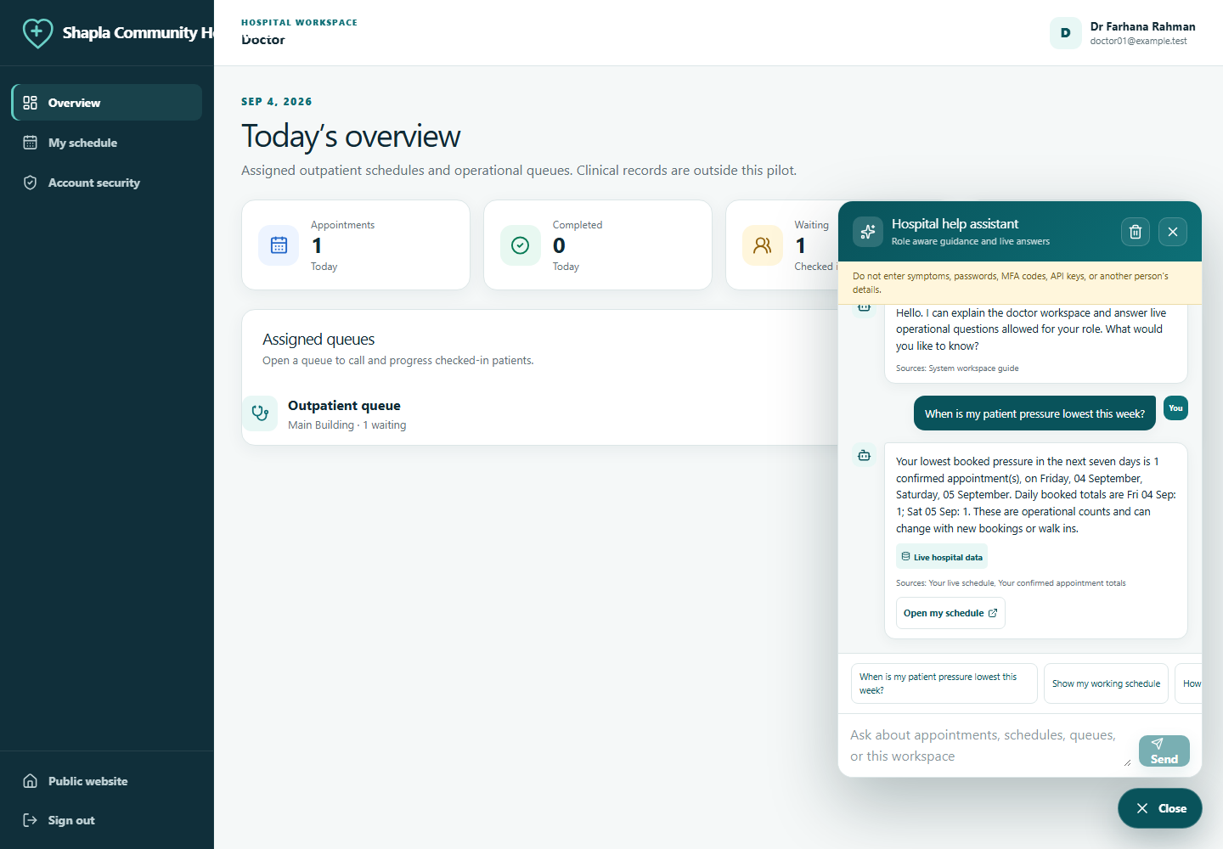
Figure 4.10: Doctor assistant workload answer
Source: Synthetic demonstration data captured from the implemented local release candidate.
The live workload answer is derived from the signed in doctor's linked schedule and appointment counts.
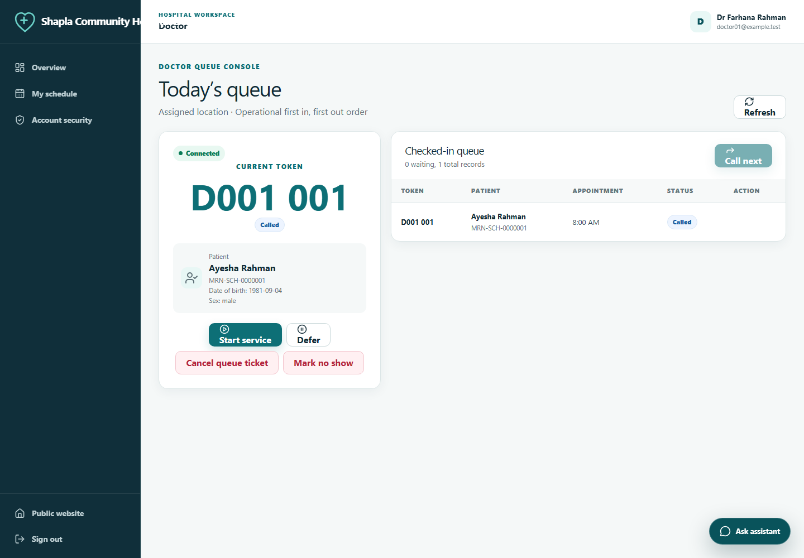
Figure 4.11: Doctor queue after calling the next patient
Source: Synthetic demonstration data captured from the implemented local release candidate.
The queue console applies a controlled state transition and displays only necessary patient identity to assigned staff.
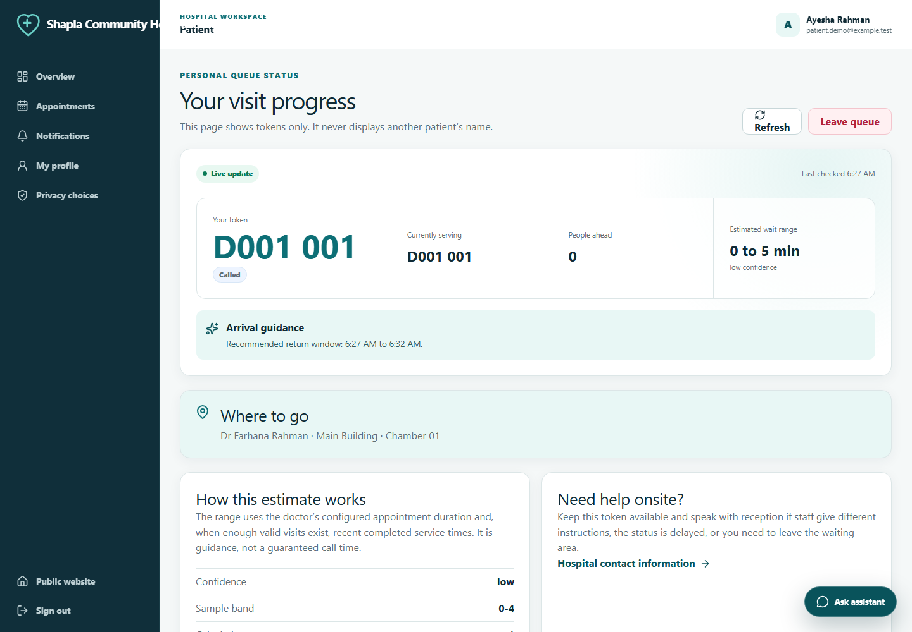
Figure 4.12: Patient live queue
Source: Synthetic demonstration data captured from the implemented local release candidate.
The patient sees token progress, an arrival range, confidence and freshness without another patient name.
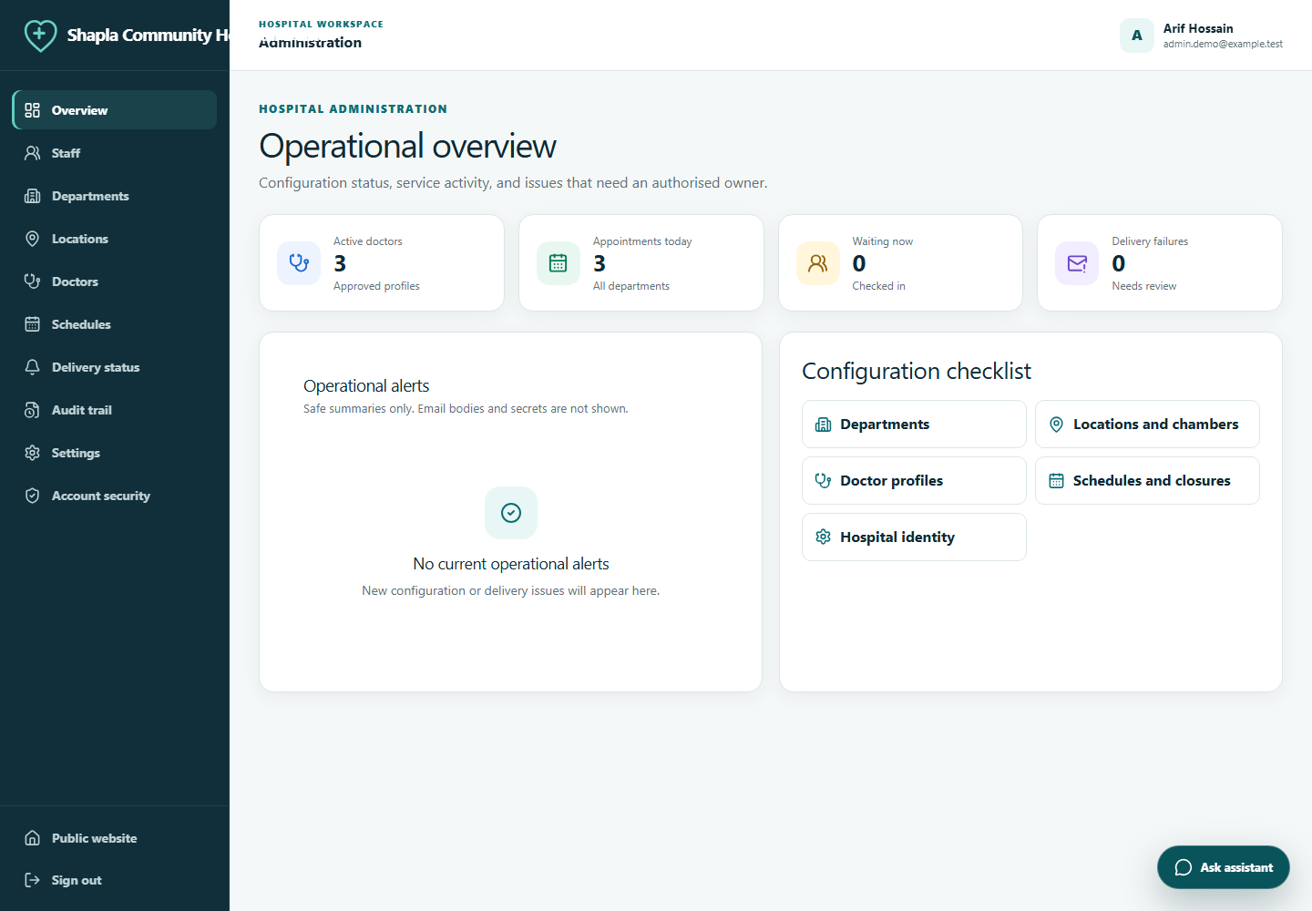
Figure 4.13: Administrator dashboard
Source: Synthetic demonstration data captured from the implemented local release candidate.
The administrative workspace provides configuration and operational oversight without bypassing normal record rules.
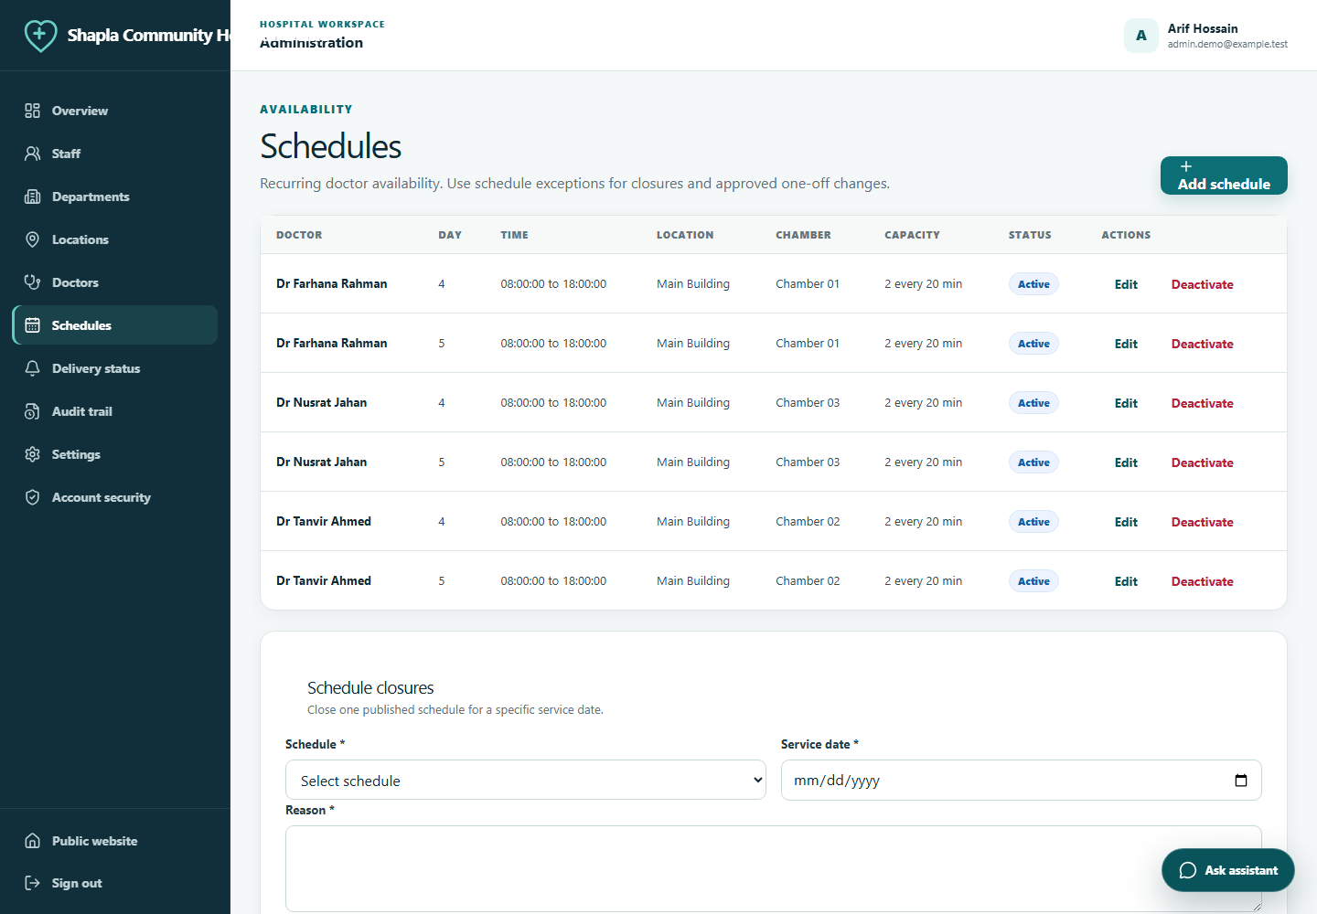
Figure 4.14: Administrator schedule management
Source: Synthetic demonstration data captured from the implemented local release candidate.
Schedule administration links doctors, chambers, effective dates, duration and slot capacity.
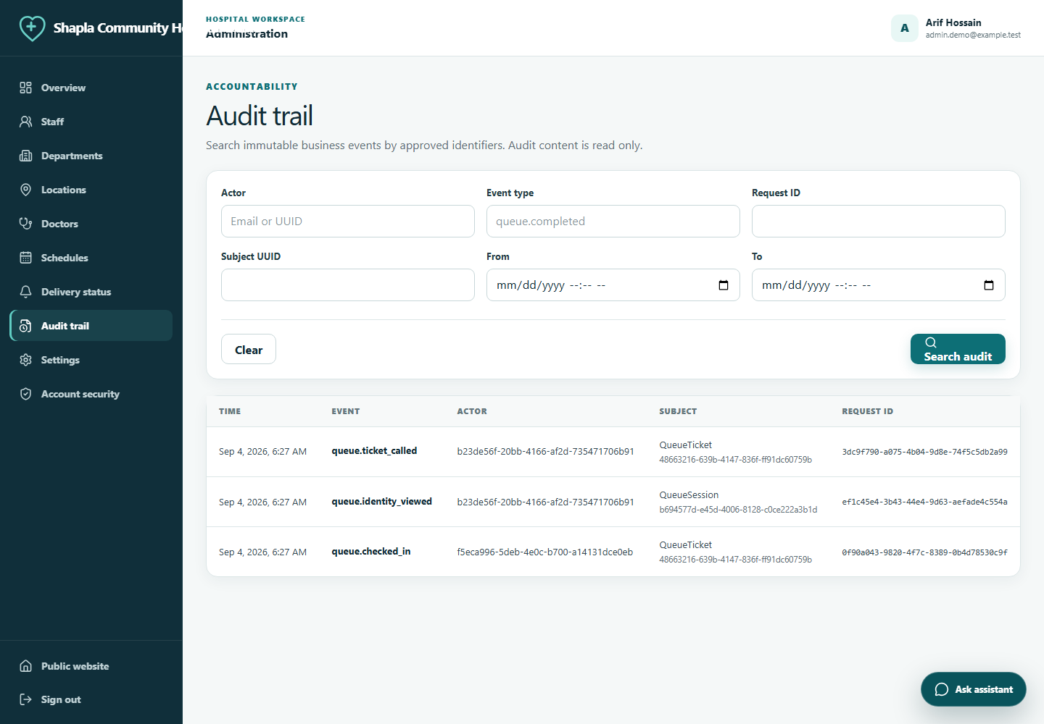
Figure 4.15: Administrator audit search
Source: Synthetic demonstration data captured from the implemented local release candidate.
Audit search exposes safe event evidence to the administrator and does not provide update or delete actions.
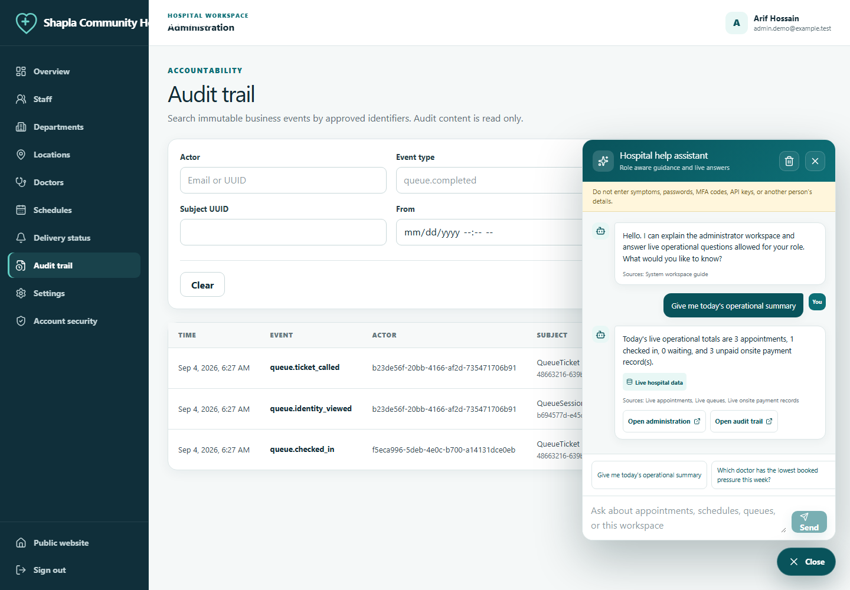
Figure 4.16: Administrator assistant summary
Source: Synthetic demonstration data captured from the implemented local release candidate.
The administrator receives approved aggregate counts and system guidance without patient names.

4.6 Software Quality Assurance
The final working tree was checked at multiple layers. Backend tests ran against PostgreSQL rather than an easier substitute. Frontend tests covered API contracts, authentication context, queue polling, shared components, formatting and the assistant. Browser tests exercised the assembled same origin system. Failure cases were asserted deliberately, so warning and error log entries produced by a test do not indicate a failed suite when the expected response and rollback are verified.
Table 4.2: Verification result summary
Evidence | Scope | Result | Interpretation
Backend suite | 129 Django tests | Passed | 87 percent line coverage; PostgreSQL 18; migrations and system check clean
Frontend suite | 57 Vitest tests in 8 files | Passed | 86.87 percent statements; 88.88 percent lines; production build passed
Browser workflow | 6 Chromium role scenarios | Passed | Public service, availability, staff MFA, reception check in, patient queue and doctor queue
Quick local load | 50 virtual users, 3,638 requests | Passed | 4.23 ms read p95 and no failed checked response in recorded local run
Backup recovery | Encrypted backup and clean isolated restore | Passed | Synthetic business records reconciled after restore
Security and supply chain | Source, dependency, image, filesystem and secret checks | Passed | Latest required GitHub checks reported no unresolved high or critical finding
Compose and image | Local, test and production rendering and build checks | Passed | Caddy validation, nonroot/read only rules and health paths checked
Hospital UAT | Named doctor, reception and administrator sign off | Pending | Must be completed on external staging before real patient approval
Full staging load | 30 minute mixed read and write workload | Pending | Requires production sized external staging and monitoring

4.7 Critical Test Scenarios
Table 4.3: Representative critical test cases
ID | Scenario | Pass condition
T01 | Two patients compete for the final slot | Exactly one booking commits; the other receives a conflict; capacity remains valid
T02 | The same booking, check in, queue or payment request repeats | The stored idempotent outcome returns and no duplicate business record appears
T03 | Two staff users call next at the same time | One ticket becomes called and the queue retains one active service position
T04 | A patient changes an appointment UUID | No other patient's record, existence detail or side effect is disclosed
T05 | A doctor requests a different doctor's queue | Role filtered lookup denies access
T06 | A patient views the live queue | Only own token and public served token are present; no other patient name is returned
T07 | Cancellation, late arrival, defer, restore, no show and completion | Only documented transitions succeed and required reasons enter history
T08 | SMTP delivery fails | Business transaction remains committed and outbox retry state advances safely
T09 | Queue polling loses connectivity | The page shows stale or reconnecting state and resumes without duplicating actions
T10 | Staff login, lockout, reset, CSRF and session expiry | Unauthorised paths fail with the stable response contract and audit evidence
T11 | Assistant question attempts prompt injection or asks for medical advice | Provider is not called; the answer refuses or returns bounded local guidance
T12 | Assistant asks for live data as each role | Patient and doctor facts remain owned; staff summaries contain approved aggregate values

4.8 Performance and Capacity Interpretation
The recorded quick local load test ramped to 50 virtual users, held for 60 seconds, and sent 3,638 checked requests through the assembled reverse proxy to public read paths. Its 4.23 millisecond p95 was well below the 500 millisecond quick gate. This proves that the tested local read path remained responsive under that narrow run. It does not prove production network latency, authenticated write capacity, long duration database behaviour, queue freshness under mixed work, or SMTP recovery.
The release workload remains a five minute ramp to 50 concurrent users, 30 minutes at that level, and five minute ramp down on production sized staging. It mixes directory and availability reads, dashboards, conditional queue snapshots, booking, reception search and check in, doctor transitions, administration reads, and notification recovery. Read p95 must remain below 500 milliseconds, write p95 below 800 milliseconds, unexpected errors below one percent, and queue freshness within 15 seconds. Business reconciliation must then prove that no capacity, token, state, payment, or outbox invariant was lost.

4.9 Results and Discussion
The implementation satisfies the defined academic and local software goals. A patient can complete the discovery and appointment path, reception can bridge scheduled and walk in patients into one queue, a doctor can operate the assigned queue, and an administrator can configure and audit the service. Queue information is more useful than a simple token because it includes a wait range, confidence and freshness. The role aware assistant reduces navigation uncertainty while remaining read only and useful without a paid provider.
The strongest technical result is not the number of pages or endpoints. It is the consistent treatment of repeated and competing actions. Idempotency controls a repeated client request, row locks control concurrent service execution, constraints protect the database, histories explain the result, and frontend feedback reports it. These layers address different failure modes and cannot replace one another.
The evidence also reveals clear limits. Automated coverage above the threshold does not prove that every hospital user understands the wording. A fast local read test does not establish production capacity. A successful isolated restore does not prove that off host credentials and incident responders are ready. The report therefore marks external UAT, full staging load, legal approval, live SMTP, final branding, and controlled pilot acceptance as pending rather than converting plans into false results.

4.10 Summary
The implemented candidate covers the intended outpatient operations, adaptive queue and role aware assistance. Automated evidence is strong for the local revision and the interface screenshots demonstrate real workflows with synthetic data. Organisational and external infrastructure gates remain before live use.

CHAPTER 5

ENGINEERING STANDARDS AND DESIGN CHALLENGES
This chapter relates the project to relevant engineering standards, evaluates its social and professional responsibilities, explains management and financial assumptions, and maps the work to complex engineering problem and activity categories.

5.1 Applicable Standards and Guidance
Table 5.1: Standards and guidance mapping
Source | Area | Project application
WCAG 2.2 AA [19] | Accessible web content | Semantic structure, keyboard operation, focus, labels, contrast, reflow, target size, errors and status messages
OWASP ASVS 5.0 Level 2 [20] | Application security verification | Authentication, session, access control, validation, data protection, API and configuration test catalogue
NIST SP 800-218 [18] | Secure software development | Tracked security requirements, protected environments, automated checks, component provenance and response to defects
NIST SP 800-63B [21] | Authentication guidance | Password, authenticator, rate limit, session and recovery design considerations
Django security guidance [22] | Framework specific protection | CSRF, host validation, HTTPS, cookies, SQL parameterisation, output handling and deployment checks
PostgreSQL 18 documentation [23], [24] | Transactional integrity | Row locking, uniqueness, check constraints and referential integrity
Bangladesh Core FHIR guide [26] | Future interoperability | Stable identifiers retained for later mapping; no conformance claim in this release
Bangladesh Government Gazette [25] | Current legal source | Qualified applicability, retention, data location and organisational review required before real data

5.2 Hardware and Software Constraints
The pilot assumes ordinary patient and staff browsers rather than dedicated devices. A receptionist benefits from a desktop display and reliable local network, while patient pages must work on narrow mobile screens. The planned VPS is intentionally modest at 4 vCPU and 8 GiB RAM. That constraint influenced the use of conditional polling and a database outbox instead of permanent socket infrastructure and a separate message broker. PostgreSQL memory, worker concurrency, connection counts, container limits, disk growth, backup age, and certificate expiry require monitoring.

5.3 Communication and Interoperability
Browser communication uses HTTPS and JSON over a versioned REST interface. The same origin arrangement makes cookie and CSRF boundaries easier to reason about. Email leaves the system only through an approved SMTP service and contains minimal operational text plus a secure link. No SMS or online payment gateway is connected. The database is not public. Future interoperability may map hospital, patient, practitioner, schedule and appointment identifiers to Bangladesh Core FHIR, but the current resources have not passed FHIR profile validation and must not be advertised as conformant.

5.4 Social, Health, Safety and Cultural Impact
A clearer appointment and queue experience can reduce unnecessary waiting and repeated enquiries. Privacy safe tokens reduce disclosure in a crowded waiting area. Bengali synthetic names and Bangladesh time and currency make the demonstration relevant to the intended environment. However, digital access can exclude people without email, confidence, literacy, vision, motor ability, or reliable connectivity. Reception assisted registration, account claiming, plain language, responsive layout, keyboard support, and a downtime paper reconciliation procedure are therefore part of the design rather than optional decoration.
Safety is protected by the nonclinical boundary. A queue estimate may help a patient plan arrival, but it must never tell a person whether symptoms are urgent. The assistant refuses medical advice and directs emergencies to the hospital's approved emergency channel. Staff retain responsibility for operational overrides, and each override leaves a reason. The system should never be used to deny care merely because a patient is not digitally connected.

5.5 Ethical and Privacy Responsibilities
Purpose limitation is the main ethical rule. Data collected to book and operate a visit should not silently become advertising, model training, or unrelated profiling data. The system stores no diagnosis, symptom, prescription, or card data. Consent points to the exact published privacy notice version. Staff access is role limited and reviewable. Demonstrations use synthetic identities. Logs and emails use minimal content. The optional assistant receives only allowlisted facts and cannot write to business records.
Transparency also applies to estimation. The patient receives a range and confidence rather than a false promise. Staff can see why an estimate was produced and must explain overrides. The hospital must approve the language used for consent, retention, incident communication, and patient correction. Legal review cannot be replaced by a software statement saying that the service is compliant.

5.6 Sustainability
The design favours a small operational footprint, supported software, container reuse, conditional responses, bounded polling and one database. Fewer services reduce idle compute, backup complexity and operator training. Sustainable operation also includes routine patching, image rebuilds, storage monitoring, deletion according to an approved retention schedule, and deactivation instead of unnecessary duplication. Accessibility and assisted workflows support social sustainability by keeping the service usable for more patients.

5.7 Project Management and Financial Analysis
The emergency delivery window required strict priority. Identity, authorization, booking integrity, queue integrity, recovery and evidence were Priority 0. Visual polish and secondary reports followed only when those controls were stable. The task register used one owner and one verifiable completion condition per item. Defects were classified by consequence; a privacy exposure, privilege error, corrupted booking, unsafe queue or failed recovery path blocked release.
Table 5.2: Cost categories for procurement
Category | Timing | Procurement note
VPS and storage | Recurring | 4 vCPU, 8 GiB RAM, NVMe host and separately approved backup storage
Domain, DNS and TLS operations | Recurring | Approved domain and monitored certificate; automated TLS certificate itself may have no licence fee
Transactional email | Recurring | Volume based approved SMTP service with bounce and delivery monitoring
Operations and support | Recurring | Named staff time for patching, access review, monitoring, backup and incident response
Security and legal review | Initial and periodic | Independent application review and Bangladesh legal or policy mapping
Training and UAT | Initial and per release | Doctor, reception, administrator and support rehearsal with synthetic records
Software licences | Low direct cost | Selected application dependencies are open source; organisational support cost remains

No vendor price is presented as a current quotation. The hospital should request local quotations for infrastructure, off host backup, SMTP, monitoring, assessment, and support, then approve a twelve month operating budget. The main financial risk is not framework licence cost; it is underfunding the people and recovery processes that keep patient operations trustworthy.

5.8 Complex Engineering Problem Mapping
Table 5.3: Mapping with complex engineering problem characteristics
Code | Characteristic | Project rationale
EP1 | Depth of knowledge | Requires web engineering, transactions, security, accessibility, queue operations, recovery and healthcare data responsibility together.
EP2 | Conflicting requirements | Fast access conflicts with privacy; flexible reception conflicts with strict integrity; freshness conflicts with simple infrastructure.
EP3 | Depth of analysis | State machines, contention, failure recovery, object authorization and estimation uncertainty require analysis beyond a CRUD application.
EP4 | Familiarity of issues | Booking pages are familiar, but fair queue overrides, cross role data minimisation and real data launch authority are less routine.
EP5 | Applicable codes | Multiple guidance sources apply and require interpretation; none alone defines the complete local design.
EP6 | Stakeholder involvement | Patients, doctors, reception, administrators, operators, institutional reviewers and legal advisers have different authority and needs.
EP7 | Interdependence | A schedule change affects capacity, appointments, queues, notifications, audit, reports, tests and recovery.

5.9 Knowledge Profile Mapping
Table 5.4: Mapping with knowledge profile
Code | Knowledge area | Application in the project
K1 | Natural sciences | Understanding that clinical service duration varies, without modelling clinical decisions.
K2 | Mathematics | Median, median absolute deviation, bounded ranges, percentiles, rate and capacity calculations.
K3 | Engineering fundamentals | Modularity, interfaces, state, concurrency, testing, observability and failure handling.
K4 | Specialist knowledge | Django, React, PostgreSQL locking, web security, MFA, containers and accessible interaction.
K5 | Engineering design | Balancing role workflow, privacy, scale, maintainability, availability and recovery.
K6 | Engineering practice | Git review, continuous integration, migrations, infrastructure definition, backup, restore and incident runbooks.
K7 | Comprehension | Explaining constraints and evidence to both technical and hospital stakeholders.
K8 | Research literature | Using peer reviewed scheduling and attendance literature plus primary technical standards.

5.10 Complex Engineering Activities
Table 5.5: Mapping with complex engineering activities
Code | Activity | Project rationale
EA1 | Range of resources | Source documents, application code, database, containers, cloud repository, standards, research, test tools and operational procedures.
EA2 | Level of interaction | Continuous coordination across four user roles, academic supervision, development, operations and approval owners.
EA3 | Innovation | Transparent adaptive arrival range and role aware live assistant integrated with transactional queue evidence.
EA4 | Consequences | A defect can expose patient identity, waste capacity, alter service order or prevent recovery, so release gates reflect consequence.
EA5 | Familiarity | Common web technologies are applied to less routine hospital workflow, privacy and concurrent state problems.

5.11 Principal Design Challenges
Table 5.6: Design challenges and resolution
Challenge | Resolution | Remaining control
No transferred application code | Built a traceable architecture and tests from the audited requirements | Hospital validates the workflow on staging
Three day completion pressure | Kept a bounded nonclinical scope and prioritised invariants | Deferred features remain explicit
Slot and queue contention | Used idempotency, locks, constraints and legal state services | Full mixed staging load and reconciliation
Useful live queue without disclosure | Used public tokens, own ticket projection, range and freshness | Waiting area observation during controlled pilot
Helpful AI without broad authority | Allowlisted context, read only endpoint, clinical refusal and local fallback | Processor approval and response review before provider use
Production claim without infrastructure | Separated completed candidate from external launch gates | Named owner must approve every real data gate

5.12 Summary
The project required choices across standards, software, operations, ethics, accessibility, cost and recovery. Its complexity comes from interdependent consequences rather than from an excessive number of technologies. The mappings show how theoretical knowledge and engineering practice meet in the implemented candidate.

CHAPTER 6

CONCLUSION
This chapter summarises the completed work, states its limitations, and identifies a controlled path for future development after the production candidate receives hospital approval.

6.1 Summary
The project transformed a basic university appointment idea into a complete nonclinical hospital operations candidate. It supports patient registration and account claiming, doctor and location configuration, scheduling and closures, capacity based booking, rescheduling, cancellation, check in, walk ins, queue control, onsite payment status, notifications, consent, audit, and role dashboards. React, Django REST Framework, PostgreSQL, Caddy and Docker are combined through one versioned same origin application.
The Adaptive Arrival Window improves the information available around a first in first out queue without pretending to perform medical triage. The role aware assistant explains the system and can answer controlled live questions while remaining read only, role scoped, and functional through its local guide when the provider is unavailable. The design protects material writes with idempotency, row locks, constraints, histories and audit evidence.
The final local revision has repeatable backend, frontend, browser, security, dependency, container, load and recovery evidence. Documentation covers planning, implementation, workflows, production, tests, defects, auditing, the advanced mechanism and the assistant. This supports academic evaluation and staging preparation. It does not remove the hospital's responsibility to approve people, policy, infrastructure and real data use.

6.2 Limitations
1. The system is a single hospital outpatient operations pilot and not an electronic medical record, hospital information suite, or clinical decision system.
2. The adaptive estimate has deterministic unit evidence but no representative real hospital dataset. Accuracy and patient benefit remain unmeasured until a controlled pilot.
3. Automated browser evidence uses pinned Chromium. The documented Firefox, WebKit, Edge, Android Chrome, mobile Safari, keyboard and screen reader sign off remains external UAT work.
4. The quick 50 user read test is not the full 30 minute authenticated mixed workload. Production capacity remains a staging gate.
5. No production domain, TLS endpoint, SMTP account, Bangladesh VPS, off host backup repository, monitoring destination, or incident rota was supplied for final activation.
6. The hospital's final identity, privacy notice, consent language, retention schedule, correction policy, downtime policy and legal mapping are not authorised by the software team.
7. The external language provider is optional. Any exposed development key must be revoked, and a replacement may be installed only in protected environment configuration after processor approval.
8. Formal FHIR conformance, SMS, online payments, insurance, laboratory, pharmacy, inpatient, inventory, payroll and multi hospital operation are outside the release.

6.3 Future Work
The immediate next work is operational rather than feature expansion. The hospital should approve branding and policies, procure staging, configure named staff and MFA, run signed role UAT, complete the mixed load test, exercise alert delivery, restore from separate storage, rehearse rollback, review the assistant's processor boundary, and operate one department with synthetic records before the real data decision.
After enough valid service history is collected, the estimate can be evaluated by doctor, day and service pattern. Any modification should remain explainable, compare against the current median baseline, report interval coverage, and undergo fairness review. A prediction model should not be introduced merely because data exists. Patient comprehension and arrival behaviour are as important as numerical error.
Later product work may include approved bilingual content, SMS through a reviewed provider, a progressive web application, richer operational reporting, integration with an existing clinical record through validated Bangladesh Core FHIR profiles, and multi location capacity. Clinical notes, prescriptions, diagnosis, triage, payment processing, or insurance would require separate governance, threat modelling, domain expertise, consent, tests and deployment approval rather than an unreviewed extension of this database.

6.4 Final Statement
A hospital system should be judged by the records it protects and the failures it handles, not only by the screens it displays. This project establishes a practical foundation for appointment and queue operations with visible limits, repeatable evidence, and a clear route from academic demonstration to a controlled hospital pilot.

REFERENCES
[1] T. Cayirli and E. Veral, “Outpatient scheduling in health care: A review of literature,” Production and Operations Management, vol. 12, no. 4, pp. 519–549, 2003, doi: 10.1111/j.1937-5956.2003.tb00218.x.
[2] T. Cayirli, E. Veral, and H. Rosen, “Designing appointment scheduling systems for ambulatory care services,” Health Care Management Science, vol. 9, no. 1, pp. 47–58, 2006, doi: 10.1007/s10729-006-6279-5.
[3] D. Gupta and B. Denton, “Appointment scheduling in health care: Challenges and opportunities,” IIE Transactions, vol. 40, no. 9, pp. 800–819, 2008, doi: 10.1080/07408170802165880.
[4] A. Ahmadi-Javid, Z. Jalali, and K. J. Klassen, “Outpatient appointment systems in healthcare: A review of optimization studies,” European Journal of Operational Research, vol. 258, no. 1, pp. 3–34, 2017, doi: 10.1016/j.ejor.2016.06.064.
[5] L. F. Dantas, J. L. Fleck, F. L. Cyrino Oliveira, and S. Hamacher, “No-shows in appointment scheduling: A systematic literature review,” Health Policy, vol. 122, no. 4, pp. 412–421, 2018, doi: 10.1016/j.healthpol.2018.02.002.
[6] J. Rivas, “Advanced access scheduling in primary care: A synthesis of evidence,” Journal of Healthcare Management, vol. 65, no. 3, pp. 171–184, 2020, doi: 10.1097/JHM-D-19-00047.
[7] D. Ansell, J. A. G. Crispo, B. Simard, and L. Bjerre, “Interventions to reduce wait times for primary care appointments: A systematic review,” BMC Health Services Research, vol. 17, art. 295, 2017, doi: 10.1186/s12913-017-2219-y.
[8] S. McLean et al., “Appointment reminder systems are effective but not optimal: Results of a systematic review and evidence synthesis employing realist principles,” Patient Preference and Adherence, vol. 10, pp. 479–499, 2016, doi: 10.2147/PPA.S93046.
[9] Y. Zhao et al., “Using digital notifications to improve attendance in clinic: Systematic review and meta-analysis,” BMJ Open, vol. 7, e012116, 2017, doi: 10.1136/bmjopen-2016-012116.
[10] D. Carreras-García, D. Delgado-Gómez, F. Llorente-Fernández, and A. Arribas-Gil, “Patient no-show prediction: A systematic literature review,” Entropy, vol. 22, no. 6, art. 675, 2020, doi: 10.3390/e22060675.
[11] E. W. Woodcock, “Barriers to and facilitators of automated patient self-scheduling for health care organizations: Scoping review,” Journal of Medical Internet Research, vol. 24, no. 1, e28323, 2022, doi: 10.2196/28323.
[12] Practo, “Practo Instant appointment booking,” Practo Help. [Online]. Available: https://help.practo.com/practo-search/what-is-practo-instant/. [Accessed: Sep. 4, 2026].
[13] Qminder, “Queue management system for healthcare,” Qminder. [Online]. Available: https://www.qminder.com/industries/healthcare/. [Accessed: Sep. 4, 2026].
[14] Doctolib, “Solutions for healthcare professionals,” Doctolib. [Online]. Available: https://about.doctolib.com/health-professionals/. [Accessed: Sep. 4, 2026].
[15] Qmatic, “Patient flow management system,” Qmatic. [Online]. Available: https://www.qmatic.com/solutions/patient-flow-management-system. [Accessed: Sep. 4, 2026].
[16] Epic Research, “Patient portal use associated with 21 million fewer visit no-shows in 2024,” Epic Research, 2025. [Online]. Available: https://media.epic.com/epicresearch/wordpressmedia/pdfs/patient-portal-use-associated-with-21-million-fewer-visit-no-shows-in-2024.pdf. [Accessed: Sep. 4, 2026].
[17] World Health Organization, Global Strategy on Digital Health 2020–2025. Geneva, Switzerland: WHO, 2021. [Online]. Available: https://www.who.int/publications/i/item/9789240020924.
[18] M. Souppaya, K. Scarfone, and D. Dodson, Secure Software Development Framework Version 1.1, NIST SP 800-218, Feb. 2022, doi: 10.6028/NIST.SP.800-218.
[19] World Wide Web Consortium, “Web Content Accessibility Guidelines 2.2,” W3C Recommendation, Oct. 2023. [Online]. Available: https://www.w3.org/TR/WCAG22/.
[20] OWASP Foundation, “Application Security Verification Standard 5.0,” OWASP, 2025. [Online]. Available: https://owasp.org/www-project-application-security-verification-standard/.
[21] National Institute of Standards and Technology, Digital Identity Guidelines: Authentication and Authenticator Management, NIST SP 800-63B-4, 2025. [Online]. Available: https://pages.nist.gov/800-63-4/sp800-63b.html.
[22] Django Software Foundation, “Security in Django 5.2,” Django documentation. [Online]. Available: https://docs.djangoproject.com/en/5.2/topics/security/. [Accessed: Sep. 4, 2026].
[23] PostgreSQL Global Development Group, “Explicit locking,” PostgreSQL 18 Documentation. [Online]. Available: https://www.postgresql.org/docs/18/explicit-locking.html. [Accessed: Sep. 4, 2026].
[24] PostgreSQL Global Development Group, “Constraints,” PostgreSQL 18 Documentation. [Online]. Available: https://www.postgresql.org/docs/18/ddl-constraints.html. [Accessed: Sep. 4, 2026].
[25] Government of the People’s Republic of Bangladesh, “Official Gazette: personal data protection instrument,” Department of Printing and Publications, 2026. [Online]. Available: https://www.dpp.gov.bd/upload_file/gazettes/61156_38449.pdf. [Accessed: Sep. 4, 2026].
[26] Management Information System, Directorate General of Health Services, Bangladesh, “Bangladesh Core FHIR Implementation Guide.” [Online]. Available: https://fhir.dghs.gov.bd/core/. [Accessed: Sep. 4, 2026].
[27] Groq, “API reference,” GroqCloud Documentation. [Online]. Available: https://console.groq.com/docs/api-reference. [Accessed: Sep. 4, 2026].
[28] Groq, “Supported models,” GroqCloud Documentation. [Online]. Available: https://console.groq.com/docs/models. [Accessed: Sep. 4, 2026].
[29] Caddy Project, “Caddy documentation,” [Online]. Available: https://caddyserver.com/docs/. [Accessed: Sep. 4, 2026].
[30] React Team, “React documentation,” [Online]. Available: https://react.dev/. [Accessed: Sep. 4, 2026].

APPENDIX A: API INVENTORY
Table A.2: Principal API endpoints
Method | Endpoint group | Purpose
GET | /health/live/, /health/ready/ | Process and dependency readiness
GET, POST | /auth/csrf/, /auth/session/, /auth/login/, /auth/logout/ | Session lifecycle
POST | /auth/mfa/verify/, /auth/mfa/confirm/, /auth/mfa/replacement/* | Staff MFA and controlled replacement
POST | /auth/register/, /auth/email/*, /auth/password/* | Patient registration, verification and password recovery
POST | /admin/staff-invitations/, /auth/staff-invitations/accept/ | Staff invitation and onboarding
GET | /public/hospital/, /public/departments/, /public/doctors/ | Public hospital directory
GET | /public/doctors/{id}/availability/ | Computed safe future slots
GET, PATCH | /me/patient-profile/, /me/consents/ | Own profile and consent history
GET, POST | /appointments/ | Role filtered list and capacity protected creation
GET, POST | /appointments/{id}/, /reschedule/, /cancel/ | Appointment detail and controlled actions
POST | /reception/appointments/{id}/check-in/, /reception/walk-ins/ | Queue entry
GET, POST | /queues/{id}/snapshot/, /call-next/ | Conditional queue projection and allocation
POST | /queue-tickets/{id}/{action}/ | Start, defer, restore, complete, no show, cancel and patient leave
GET, POST | /appointments/{id}/payment/, /payment/actions/ | Onsite payment record and history
GET, POST | /notifications/, /notifications/{id}/read/ | Own notifications
GET, PATCH | /notification-preferences/ | Allowed notification choices
GET, POST | /admin/* | Settings, privacy, directory, schedules, outbox and audit
POST | /assistant/chat/ | Bounded read only role aware help

APPENDIX B: DETAILED MANUAL TEST CATALOGUE
Table B.1: Manual role test catalogue
Role | Action | Expected result
Public | Open home, doctor directory, doctor detail, about, contact and privacy | Every link resolves, responsive layout holds and no private data appears
Patient | Register against active notice, verify email, sign in and review profile | MRN is unique, consent names the notice version and only own data appears
Patient | Book last available position from two sessions | One confirmation and one capacity conflict
Patient | Reschedule then cancel | Old capacity returns, new capacity reserves, reason and history remain
Reception | Search, duplicate check, create unclaimed patient and claim invitation | No automatic merge and single use invitation
Reception | Create walk in and check in scheduled patient | One appointment and one token per patient action
Reception | Record paid onsite, waiver, refund and correction | Role, reason, amount and history remain; no card field exists
Doctor | Call, start, defer, restore, complete and no show | Only own queue changes through legal states
Patient | Observe queue during doctor actions and network loss | Own token only, freshness changes and reconnect recovers
Administrator | Invite staff, configure directory and create schedule exception | Every change is scoped, validated and audited
All roles | Ask the assistant for navigation and live facts | Answer matches role, contains safe sources and causes no write
All roles | Attempt another user's UUID and inject extra fields | Stable denial or validation response with no protected content
Operations | Stop worker during appointment action, then resume | Business action remains; notification retries once safely
Operations | Restore encrypted backup into clean isolated database | Known business totals and integrity queries match

APPENDIX C: DEMONSTRATION ACCOUNTS
The repository seed command creates deterministic synthetic accounts for local demonstration only. Their addresses use the reserved example.test domain. The shared synthetic password and TOTP enrollment values are documented in the private demonstration procedure rather than repeated in this report. They must never be copied to staging or production. Production staff accounts are named invitations with separately enrolled MFA.
Table C.1: Synthetic demonstration identities
Role | Email | Purpose
Patient | patient.demo@example.test | Booking, own appointment, queue, notification, profile and assistant
Doctor | doctor01@example.test | Own schedule, assigned queue and workload assistant
Receptionist | reception.demo@example.test | Patient, appointment, check in, walk in, queue and payment
Administrator | admin.demo@example.test | Staff, directory, schedules, settings, audit, outbox and summary assistant

APPENDIX D: DEPLOYMENT AND GO LIVE CHECKLIST
1. Approve hospital name, logo, contacts, privacy notice, consent language, retention schedule, access rules, correction process and incident contacts.
2. Complete qualified review of current Bangladesh law, data location, processor terms and hospital obligations.
3. Provision Bangladesh hosted VPS, domain, DNS, HTTPS, protected deployment account, SMTP, monitoring and separate encrypted backup storage.
4. Install independently generated environment secrets. Keep the MFA encryption key stable and separate from Django, database, SMTP and backup credentials.
5. Deploy immutable image digests, validate configuration, run migrations through the owner role and verify runtime database restrictions.
6. Create the hospital record and active notice, then configure departments, locations, chambers, doctors, schedules and named staff.
7. Run the full automated suite, current dependency and image scans, deployment smoke, external TLS check and monitored mixed staging load.
8. Restore a current encrypted off host backup into a clean environment, reconcile business records and record achieved RPO and RTO.
9. Rehearse application rollback, schema compatibility decision, notification failure, downtime paper operation and later reconciliation.
10. Obtain signed patient, doctor, receptionist and administrator UAT for the exact release revision.
11. Verify no Severity 1 or 2 defect and no critical or high security finding remains.
12. Run one controlled department pilot and review incidents, queue estimate quality, accessibility, support demand and patient feedback before expansion.

APPENDIX E: REQUIREMENT TRACEABILITY
Table E.1: Requirement to implementation and evidence mapping
Requirement | Implementation evidence | Verification evidence
FR01–FR09 | Accounts and directory models, public and admin APIs, public and admin pages | Backend directory and identity tests, browser public and MFA workflows
FR10–FR12 | Appointment services and patient or reception pages | Capacity, idempotency, state, ownership and concurrent booking tests
FR13–FR16 | Queue services, snapshot API, reception, doctor and patient queue pages | Check in, call next, transitions, privacy, ETag and polling tests
FR17–FR19 | Payment, communication and audit records and interfaces | Payment state, outbox retry, append only and audit permission tests
FR20–FR21 | Assistant endpoint, role context and widget | Role scoping, provider failure, injection, clinical refusal and component tests
FR22 | Hospital settings and privacy notice administration | Configuration, notice activation and consent tests
NFR01–NFR03 | Session, CSRF, MFA, role filtering, transactions, constraints and audit | Security, permission, concurrency, history and secret scans
NFR04–NFR06 | Health, production topology and load scripts | Local health and quick load passed; external availability and full load pending
NFR07 | Accessible components and responsive pages | Automated component and Chromium checks; hospital screen reader sign off pending
NFR08–NFR12 | Backup, restore, logs, documentation, nonclinical boundary | Local restore and automated gates passed; off host restore and external approvals pending

APPENDIX F: SUBMISSION ARTIFACT INDEX
The submission is reproducible from the private repository. The original university template remains unchanged. Generated quality assurance pages and temporary build files are review evidence, while the following maintained artifacts define the system and final submission.
Table F.1: Maintained submission artifacts
Artifact | Purpose
deliverables/Hospital Management System Final Report.docx | Final report based on the supplied FYDP format
report_assets/screenshots/ | Fifteen synthetic interface captures used by Chapter 4
report_assets/diagrams/ | Eight reproducible architecture and workflow diagrams
implementation_plan.md | Architecture, data model, API, permissions and build sequence
production.md | Environment, deployment, monitoring, backup, restore, rollback and incident procedures
test.md | Quality strategy, completed evidence and remaining external release gates
audit.md | Source traceability, contradiction review, privacy analysis and risk register
workflow.md | Patient, staff, queue, release and correction workflows
advanced_mechanism.md | Adaptive Arrival Window formula, fairness evidence and limitations
chatbot.md | Role aware assistant knowledge, live data boundary and provider setup
bugs.md and tasks.md | Defect rules, active status, backlog, ownership and acceptance conditions
scripts/report/ | Repeatable report, diagram, field update, rendering and QA tools

